|  |  |
| --- | --- |
| MITRE Logo |  |
|  | CDC Cervical Cancer Computable Guidelines: Clinical Decision Support (CDS) for Cervical Cancer Screening and Management Implementation Guide (IG) |
| **Sponsor:** Department of Health and Human Services, Centers for Disease Control and Prevention (CDC)  **Contract No.:** 75FCMC18D0047  **Project No.:** 37208168 | Version 2.2 |
| The views, opinions and/or findings contained in this report are those of The MITRE Corporation and should not be construed as an official government position, policy, or decision, unless designated by other documentation.  ©2022 The MITRE Corporation.  All rights reserved.  **McLean, VA** | January 2022  Approved for Public Release; Distribution Unlimited. Public Release Case Number 22-0498 |

Record of Changes

|  |  |  |  |
| --- | --- | --- | --- |
| Version | Date | Author / Owner | Description of Change |
| 1.0 |  | MITRE | Draft Version 1.0 |
| 2.0 |  | MITRE | Final Version 2.0 |
| 2.1 |  | MITRE | Final Version 2.1 with feedback incorporated |
| 2.2 |  | MITRE | Updates based upon stakeholder feedback |

Table of Contents

1 Introduction 1

1.1 Background 1

1.2 Purpose 2

1.3 Scope 3

1.4 Audience 3

1.5 Document Organization 3

2 Project Overview 3

3 CDS Overview 4

3.1 CDS Evidence Base 5

3.1.1 Primary Evidence-based Guidelines 5

3.1.2 Additional Supporting Guidelines and Evidence 5

3.2 Clinical Workflow Conceptual View 6

3.3 CDS Approach 7

3.4 CDS Modular Design 8

4 Overview of the CDS L2 Representation 9

4.1 CDS Logic Path Descriptions 9

4.1.1 Logic Path 1 – Symptomatic Individuals 9

4.1.2 Logic Path 2 – Individuals Exposed to DES in Utero 10

4.1.3 Logic Path 3 – Immunocompromised Individuals 10

4.1.4 Logic Path 4 – Cervical Cancer Screening for “Average-risk” Individuals 10

4.1.5 Logic Path 5 – Individuals who Require Management of Abnormal Cervical Cancer Screening Tests and Cancer Precursors 10

5 Overview of the L3 CDS Representation 10

5.1 Interoperability Standards for CDS Definition 11

5.1.1 Fast Healthcare Interoperability Resources (FHIR®) 11

5.1.2 FHIR Clinical Reasoning Module 11

5.1.3 FHIR Clinical Guidelines Implementation Guide 11

5.1.4 Clinical Quality Language 12

5.2 CDS Structure via FHIR 12

5.2.1 Screening CDS 12

5.2.2 Management CDS 13

5.3 CDS Logic via CQL 14

5.4 Conceptual CDS Usage 15

5.4.1 FHIR $apply Operation 15

5.4.2 Examples 15

5.5 CDS L3 Source Code 17

6 CDS Testing & Validation 17

6.1 Test Driven Development (TDD) 17

6.2 Types of Testing 18

6.2.1 Specification Testing 18

6.2.2 Unit Testing with Test Cases 19

6.2.3 End-to-End Testing 19

6.3 Testing Support Tools 20

6.3.1 FHIR Validator 20

6.3.2 CQL-to-ELM Translator 20

6.3.3 CQL Execution Tools 20

6.3.4 CQL Testing Framework 21

6.3.5 Synthea 21

6.3.6 Encender 21

6.3.7 CCSM Dashboard Prototype 21

7 CDS Integration 22

7.1 Interoperability Standards for CDS Integration 22

7.1.1 Sustainable Medical Applications, Reusable Technologies (SMART®) 22

7.1.2 CDS Hooks 22

7.2 Integration Options 23

7.2.1 Option 1: SMART 23

7.2.2 Option 2: CDS Hooks 24

7.2.3 Option 3: CDS Hooks and SMART 24

7.3 Requirements 24

7.3.1 Functional Requirements 24

7.3.2 Data Requirements 25

7.4 Data Mapping 25

7.5 Handling Unstructured Data 25

7.5.1 Allow Clinician Input 25

7.5.2 A Natural Language Processing (NLP) Application Programming Interface (API) 26

8 References 26

Appendix A Lists of Test Cases 32

Appendix B Data Requirements Table 38

List of Figures

Figure 1. The four knowledge levels of CDS [12] 4

Figure 2. CCSM Conceptual Clinical Workflow 7

Figure 3. Theoretical Depiction of CCSM Clinician-Facing Dashboard 8

Figure 4. High Level CDS Flow Diagram 9

Figure 5. Diagram of Screening CDS 13

Figure 6. Diagram of Management CDS 14

Figure 7. Illustration of the FHIR $apply operation 15

Figure 8. Notional $apply example (screening for average risk individual) 16

Figure 9. Notional $apply example (screening for immunocompromised individual with EHR errors) 17

Figure 10. Illustration of test-driven approach for developing the CCSM CDS. 18

Figure 11. Diagram showing integration approaches taken by SMART and CDS Hooks. 23

List of Tables

Table 1. Test Cases for Screening with Symptomatic Individuals 32

Table 2. Test Cases for Screening with Individuals Exposed to DES 32

Table 3. Test Cases for Screening with Immunocompromised Individuals 32

Table 4. Test Cases for Screening with Individuals of Average Risk 33

Table 5. Test Cases for Management of Common Abnormalities (Risk Table 1: Screening) 34

Table 6. Test Cases for Management of Common Abnormalities (Risk Table 2: Surveillance) 34

Table 7. Test Cases for Management of Common Abnormalities (Risk Table 3: Colposcopy Results) 35

Table 8. Test Cases for Management of Common Abnormalities (Risk Table 4: Post Colposcopy) 35

Table 9. Test Cases for Management of Common Abnormalities (Risk Table 5: Post Treatment) 36

Table 10. FHIR Data Requirements for this Artifact 38

# Introduction

The Centers for Disease Control and Prevention’s (CDC’s) Division of Cancer Prevention and Control partnered with the CMS Alliance to Modernize Healthcare federally funded research and development center (Health FFRDC) on a multi-year effort to develop clinical decision support (CDS) tools. CDC and the Health FFRDC developed these tools to encourage awareness and adoption of the most up-to-date cervical cancer screening guidance and the new risk-based approach for managing abnormal screening results. The project team intends for the CDS to help clinicians provide cervical cancer screening and management (CCSM) care based on updated guidelines from several organizations including the United States Preventive Services Task Force (USPSTF) and the American Society for Colposcopy and Cervical Pathology (ASCCP). The Health FFRDC is developing the CDS using a reproducible process, utilizing interoperable health information technology (IT) standards including Health Level 7 International (HL7®) Fast Healthcare Interoperability Resources (FHIR®) [1] and the Clinical Quality Language (CQL) [2].

This document describes the purpose and intended use of the CDS for CCSM, options for integration of the CDS components with electronic health records (EHRs), and testing and verification for ensuring the CDS software performs as expected.

## Background

The introduction of routine screening using the Papanicolaou (Pap) test decreased the incidence of cervical cancer significantly, making it possible to find and treat precancerous lesions before they progress to cancer [3]. Prior to the Pap test, cervical cancer was one of the leading causes of cancer-related deaths for women in the U.S. [3]. Today, cervical cancer is highly preventable when detected early and managed according to screening and management guidelines. Nevertheless, it continues to be a significant public health concern in the U.S with 12,733 new cervical cancer cases diagnosed and 4,138 cervical cancer-related deaths according to latest incidence data recorded in 2018. In addition, an estimated 196,000 cases of high-grade cervical precancer are diagnosed each year [4]. U.S. data also shows that racial and socioeconomic disparities in cervical cancer screening, incidence, and mortality [3]. Timely screening and follow-up could identify and treat cervical precancer and ultimately reduce the number of cervical cancer cases and deaths diagnosed each year from this preventable malignancy.

Cervical cancer screening and management has steadily improved over the past 15 years. The use of human papillomavirus (HPV) tests as part of routine cervical cancer screening (more recently as a stand-alone test) and the discovery of performance gaps in existing screening and management programs have contributed to improvements [3]. According to the 2018 USPSTF recommendation, cervical cancer screening substantially reduces disease incidence and mortality in women aged 21 to 65 years [4]. In addition to the USPSTF cervical cancer screening guidelines, new guidelines were issued by American Cancer Society, the American College of Obstetrics and Gynecologists (ACOG) and a Consensus Group convened by ASCCP. Updates and changes reflected in the CCSM guidelines include the following:

* In 2018, the USPSTF issued new screening guidelines that incorporate primary HPV testing as one of three strategies to screen for cervical cancer. Adoption of the new guidelines will take time due to limited access to primary HPV testing, physician and patient acceptance, and the changes required to laboratory infrastructure to accommodate this screening method [5, 6].
* In 2019, ASCCP issued new risk-based consensus guidelines for managing abnormal screening results in 2019. These guidelines are designed to be enduring, unlike prior versions which require major updates every 5-10 years [7]. A major improvement in the new guidelines is their use of individualized risk assessments. Risk is assessed using patient history and current exam results. Publicly available risk estimate tables help clinicians calculate individualized patient risk; however, they are burdensome to use because they require manual input of each patient-specific data element.
* In 2020, the American Cancer Society (ACS) issued new guidelines to start screening at a slightly older age and preferentially recommend screening by HPV testing [8].
* In 2021, ACOG endorsed the 2018 USPSTF cervical cancer screening recommendations.

The increased complexity and routine update of CCSM guidelines makes it challenging and error prone for clinicians to stay abreast of the latest evidence that guides screening recommendations and management of abnormal results. Management of abnormal results may require tracking tests and procedures from multiple settings, and primary care physicians may not have the capacity to follow up many sets of results. By transforming CCSM narrative guidelines into a computable format and made available as CDS tools, these guidelines can be integrated with EHR platforms to assist clinicians and ultimately improve patient outcomes.

For primary care providers with multiple competing priorities, the CDS can more efficiently evaluate a patient’s clinical data against CCSM guidelines and display screening or management recommendations. The CDS may also be beneficial in resource-constrained settings where access to clinical specialists is limited. Level of care is often variable, and disparities exist for vulnerable, underserved patient populations. The barriers contributing to these disparities are complex and include but are not limited to: socio-economic issues, including scarce resources in rural and remote areas; language barriers due to ethnicity and race; educational levels that lead to difficulty in understanding patient education materials; and lack of technology to access resources [9]. In rural settings using an EHR, the CDS may support clinicians with the knowledge base to efficiently identify evidence-based screening or management recommendations.

Interoperable CDS tools have the promise to support efforts championed by the CDC’s Adapting Clinical Guidelines for the Digital Age initiative [10] and the Agency for Healthcare Research and Quality’s (AHRQ’s) CDS Connect project [11]. When clinical guidelines are co-developed with the CDS that expresses their guidance, computable representation reduces duplication of effort across the healthcare ecosystem and diminishes the chances for mistranslation of guidelines. The CCSM CDS developed for this project is a proof-of-concept effort to represent clinical guidelines in a shareable, structured, and computable format to facilitate meaningful improvements in the number of women screened and treated for cervical precancer.

## Purpose

The primary purpose of this implementation guide is to provide guidance to healthcare organizations regarding how to implement and operate the CDS tools in their EHR and evaluate their performance. In support of this activity, the document provides a description of the following areas:

* CCSM guidelines that informed development of the CDS tools
* CCSM clinical workflow and how the CDS integrates with patient care
* CDS design approach
* Semi-structured (i.e., human readable) logic, also referred to as Level 2 (L2) logic
* Structured (i.e., coded) logic, also referred to as Level 3 (L3) logic

## Scope

This document provides guidance for end-users and implementors of the CCSM CDS tools. It includes information about the project background, CDS design details, EHR integration, and use in a clinical setting.

## Audience

Various audiences may find the information in this implementation guide helpful, including:

* **Clinicians, Quality Improvement Leaders and Health Administrators** at healthcare organizations and primary care practices who wish to implement, test, and execute CDS related to CCSM in their health IT systems.
* **CDS Developers and Informaticists** who may use components of this CDS logic as a foundation for other preventive health CDS, or who want to use well-developed structured logic and CQL in their own work.
* **Community-based** **Organizations** interested in using CCSM CDS tools to promote women’s health and the importance of cervical cancer screening and follow-up.
* **Health IT Administrators** interested in understanding how the CCSM CDS tools are specified to inform implementation of the CDS in their IT system.

## Document Organization

This document is organized as follows:

* Section 2 – Project Overview
* Section 3 – CDS Overview
* Section 4 – Overview of the Level 2 CDS Representation
* Section 5 – Overview of the Level 3 CDS Representation
* Section 6 – CDS Testing & Validation
* Section 7 – CDS Integration
* Section 8 – References
* Appendix A – List of Test Cases
* Appendix B – Data Requirements

# Project Overview

The Health FFRDC is developing interoperable CDS tools to increase awareness and adoption of CCSM guidelines. The tools will assist clinicians with identifying individuals due for cervical cancer screening and reduce the complexity of making risk-based care decisions. The tools are being developed using international health IT standards to support interoperability and a modular approach to facilitate adaptation, configurability, and future updates.

The project is currently in year one of a multi-year effort. The project timeline and key milestones for the three-year effort are as follows:

* **Define CDS in Year 1** – Conduct an environmental scan, develop CDS definitions, test fixtures and software, and create an implementation guide.
* **Pilot CDS in Year 2** ­– Identify pilot partners, conduct pilot integration of CDS with EHRs in a clinical setting; quantify CDS effectiveness.
* **Develop Quality Measures in Years 2 & 3** – Specify companion electronic clinical quality measures (eCQMs) to measure care alignment with CCSM guidelines before and after CDS implementation.
* **Promote Adoption in Year 3** – Develop a communication strategy to disseminate and share the CDS, including promotion of CDS tools and resources on AHRQ’s CDS Connect repository.

# CDS Overview

This section includes a list of the guidelines that informed development of the CCSM CDS, a conceptual diagram that describes the CCSM clinical workflow, and information about the CDS design approach.

Diagram showing the four knowledge levels of CDS:
1. Narrative (Level 1)
2. Semi-structured (Level 2)
3. Structured (Level 3)
4. Executable (Level 4)

Figure 1. The four knowledge levels of CDS [12]

The initial phase of this work includes the completion of an environmental scan to investigate existing clinical practice guidelines, quality measures, and EHR capabilities in the domain of CCSM. This scan serves as the groundwork for iteratively progressing through the four knowledge levels of CDS represented in Figure 1:

* Level 1, Narrative: The CDS evidence base represents the L1 narrative representation of the guidelines.
* Level 2, Semi-Structured: The L2 semi-structured logic for screening and management was created using the evidence based L1 narrative guidelines.
* Level 3, Structured: The L3 structured logic representation of the CCSM guidelines was developed to make computable the evidence-based content and recommendation statements selected for L2 logic representation.
* Level 4, Executable: The CDS L3 representation is expressed in a machine-processable format, based on the logic that should be triggered and the recommended care that should result.

The Health FFRDC will ensure that this CDS is expressed as standards-based interoperable code that can be integrated with a health IT system (e.g., using standard health terminologies and FHIR).

## CDS Evidence Base

The CCSM CDS tools were designed to represent two primary guidelines: 1) the 2018 USPSTF guidelines for screening individuals with an average risk of cervical cancer, and 2) the 2019 ASCCP Risk-Based Management Consensus Guidelines for managing abnormal cervical cancer screening results. Additional supporting evidence listed in this section helped to fill in gaps when certain populations were excluded from the primary guidelines (e.g., individuals who are immunocompromised or experiencing abnormal bleeding). There are multiple evidence-based average-risk cervical cancer screening guidelines published with differences in age thresholds and preferred screening tests. The CCSM CDS tools are designed in alignment to the USPSTF cervical screening guidelines for reasons including:

* The Affordable Care Act includes provisions to improve access to certain preventive health services as recommended by the USPSTF.
* Cervical cancer screening clinical quality measures used in CMS quality reporting programs, HRSA UDS reporting, and NCQA HEDIS are based on USPSTF guidelines.
* The National Breast and Cervical Cancer Early Detection Program (NBCCEDP) screening recommendations are based on USPSTF guidelines.
* The need to address barriers of availability and access to primary HPV testing.

### Primary Evidence-based Guidelines

* Average-Risk Cervical Cancer Screening
  + *[2018 U.S. Preventive Service Task Force Recommendation Statement: Screening for Cervical Cancer](https://www.uspreventiveservicestaskforce.org/uspstf/recommendation/cervical-cancer-screening)* [[13]](https://www.uspreventiveservicestaskforce.org/uspstf/recommendation/cervical-cancer-screening)
* Management of Abnormal Cervical Cancer Screening Results
  + [*2019 ASCCP Risk Based Management Consensus Guidelines for Abnormal Cervical Cancer Screening Tests and Cancer Precursors*](https://www.asccp.org/management-guidelines)[7]
  + [*Risk Estimates Supporting the 2019 ASCCP Risk-Based Management Consensus Guidelines*](https://www.asccp.org/management-guidelines)[14]

### Additional Supporting Guidelines and Evidence

* *Evaluation of Abnormal Uterine and Vaginal Bleeding: ASCCP Clinical Practice Statement: Evaluation of the cervix in patients with abnormal vaginal bleeding, 2017* [15]
* Cervical Cancer Screening for Individuals with Diethylstilbestrol Exposure (DES) In Utero
  + As of October 2021, there are no evidence-based guidelines for this population. Previous guidelines that provided care recommendations include the following:
    1. *Cervical Cancer Screening and Prevention Practice Bulletin No.168* [16]
    2. *Antenatal Exposure to DES: Lessons Learned…Future Concerns* [17]
* Cervical Cancer Screening for Immunocompromised Individuals
  + [*Guidelines for Prevention and Treatment of Opportunistic Infections in Adults and Adolescents with Human Immunodeficiency Virus (HIV*](https://www.cdc.gov/mmwr/preview/mmwrhtml/rr58e324a1.htm)*)* [18]
  + [*Guidelines for Screening of Immunosuppressed Women without HIV Infection*](https://pubmed.ncbi.nlm.nih.gov/30907775/)[19]

## Clinical Workflow Conceptual View

The Health FFRDC team synthesized findings from subject matter experts (SME) to develop a conceptual CCSM clinical workflow (Figure 2). There are three main participants in this workflow – patients, clinicians, and pathologists. The flow consists of the following steps:

* A patient enters the process when due for screening
* Clinician reviews the patient’s prior history and consults the appropriate guidelines
* During the visit, screening is performed based on criteria for average-risk or high-risk individuals
* Screening test is sent to the lab for analysis
* Results are communicated to the patient and clinician, and the patient and clinician determine next steps to continue routine screening or manage abnormal screening results.

A quadrant graphic depicting the CCSM conceptual clinical workflow:
Laboartory facing
Patient facing
and
Clinician facing
all with a shared decision making model.

Figure 2. CCSM Conceptual Clinical Workflow

Findings from the robust environmental scan showed a general need to (1) increase awareness and understanding of updated cervical cancer guidelines, and (2) align CDS to the clinical workflow of clinicians and pathologists to deliver evidence-based care. The following clinical needs were identified:

* Increased understanding of multiple screening and management options based on the patient’s risk as part of the shared decision-making process between patient and provider.
* Facilitate more consistent implementation of EHR features (e.g., reminders, worklists, documentation templates) to support screening and management activities.
* Provide a centralized view of relevant screening and management information (e.g., previous screening results, procedures, relevant medical history).
* Include the calculation of cervical intraepithelial neoplasia (CIN) risks.

Additional needs, particularly from the patient perspective, include the ability to facilitate shared decision making that incorporates patient preferences. This might include preferences related to the type of screening test used, communication methods, noting the patient’s primary language, and preferred learning style. Tailoring to patient preferences helps to establish patient trust.

## CDS Approach

Findings from the environmental scan revealed that staying informed of evolving CCSM guideline updates and implementing that guidance to make evidence-based care decisions is challenging and time consuming for clinicians. This is due to the broad array of data that needs to be considered when making a screening or management care decision and the complex risk estimates used to determine the plan of care if the patient has a history of abnormal screening results. To help clinicians overcome these challenges, the proposed CCSM CDS tools are designed to identify relevant CCSM clinical data from the patient electronic health record so it can be summarized and displayed to the clinician in a user-friendly dashboard. The types of relevant CCSM clinical data include the following:

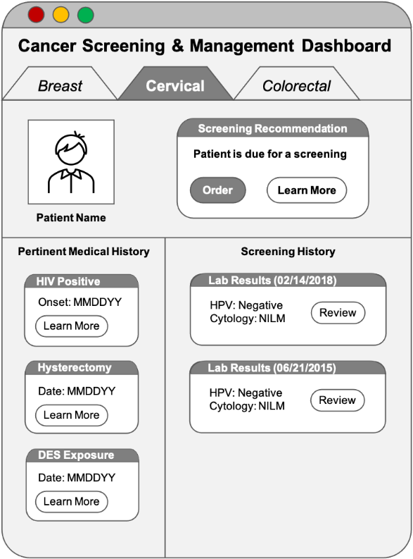

* Age (calculated using date of birth)
* Relevant Medical History (e.g., diagnosis of cervical cancer or precancer, in utero DES exposure, evidence of immunocompromised conditions)
* Relevant Procedures (e.g., hysterectomy with removal of the cervix, colposcopy)
* Relevant Medications (e.g., immunosuppressants)
* Relevant Screening and Histology Results (e.g., cervical cytology)

Figure 3. Theoretical Depiction of CCSM Clinician-Facing Dashboard

Figure 3 is a notional depiction of how the compiled data might be displayed in an EHR as a CCSM dashboard. The computable logic created during Year 1 will determine (1) if dashboard information should be displayed, (2) what historical information should be included in the dashboard, (3) when screening is due, and (4) the type of screening indicated based on the patient’s level of cervical cancer risk. True “mockups” of how the dashboard might look in a health IT system and how the clinician might interact with the dashboard will be designed and developed during Year 2 of this project.

## CDS Modular Design

A modular approach is central to the design and implementation of this CDS to support the clinical needs mentioned above. A modular approach offers several benefits in terms of interoperability, adaptability, and reusability. Building individual components as part of this project allows for the components to be assembled in multiple ways to address different use cases (e.g., clinical and quality improvement needs). Each use case will have its own specific requirements related to the system or workflow it is intended to work with. As with any interoperable approach, these modular components will be assembled into an operational CDS application and configured (with additional integration code) to work with or within a health IT system.

Taking this type of modular approach is not new, and it is not novel to the Health FFRDC. There are many organizations that build CDS systems this way and many examples of these modular approaches. For more on this modular approach to CDS, see the [FHIR Clinical Guidelines IG](https://build.fhir.org/ig/HL7/cqf-recommendations/) [20].

# Overview of the CDS L2 Representation

This section provides an overview of the CCSM CDS L2 representation. The high-level flow diagram displayed in Figure 4 outlines five distinct CDS logic paths. Each path addresses a different patient population (based on the patient’s symptoms, past medical history, and previous screening results), and identifies the corresponding guidelines that outlines patient care recommendations. See the companion *Cervical Cancer Screening and Management Clinical Decision Support Level 2 Semi-structured Logic* document to view more granular depictions of each path’s CDS flow, along with the full L2 specification.

A workflow diagram depicting 4 logic paths:
Symptomatic pre-screening
DES exposure in utero screening
Immunocompromised individuals screening
Average risk cervical cancer screening 

Figure 4. High Level CDS Flow Diagram

## CDS Logic Path Descriptions

This section provides insight on the target patient population for each logic path and the evidence that informed development of the logic and care recommendations.

### Logic Path 1 – Symptomatic Individuals

Per the USPSTF and ASCCP cervical cancer guidelines, clinicians should perform a diagnostic work-up (which includes cervical cytology) on individuals who present as symptomatic (i.e., have abnormal vaginal or uterine bleeding). [7, 13, 15] If the individual’s cervix is visibly abnormal, additional care is recommended per *Evaluation of Abnormal Uterine and Vaginal Bleeding: ASCCP Clinical Practice Statement: Evaluation of the cervix in patients with abnormal vaginal bleeding, 2017.* [13]

### Logic Path 2 – Individuals Exposed to DES in Utero

Historically, individuals exposed to DES in utero were considered to have a higher-than-average risk of cervical cancer, and therefore have unique screening requirements [13, 17, 16]. This CDS tool notifies a clinician that an individual had DES exposure in utero and prompts consideration of individualized care. It also provides links to historical evidence for contextual information.

### Logic Path 3 – Immunocompromised Individuals

Immunocompromised individuals are also considered to have a higher-than-average risk of cervical cancer, and therefore have unique screening requirements [13, 19, 18]. Care recommendations generated for immunocompromised individuals in logic path 3 were informed by evidence published by the CDC/HIV Panel and Moscicki et al. More specifically, the CDC/HIV Panel guidelines define screening and management recommendations for individuals with HIV, and Moscicki et al. defines additional immunocompromised criteria for individuals who qualify for screening and management care described in the CDC/HIV Panel guidelines.

### Logic Path 4 – Cervical Cancer Screening for “Average-risk” Individuals

The USPSTF S*creening for Cervical Cancer* recommendation statement provides guidance on cervical cancer screening for average risk individuals (i.e., individuals who are not immunocompromised, have not had in utero exposure to DES, and do not have a history of high-grade precancer or cervical cancer). [13] The USPSTF recommends cervical cancer screening every three years with cervical cytology alone for individuals aged 21 to 29 years. [13] For individuals aged 30-65 years, the USPSTF recommends screening every three years with cervical cytology alone, every five years with high-risk human papillomavirus (hrHPV) testing alone, or every five years with hrHPV testing in combination with cytology (cotesting) [13].

### Logic Path 5 – Individuals who Require Management of Abnormal Cervical Cancer Screening Tests and Cancer Precursors

The ASCCP states that risk-based management guidelines apply to patients with current or previous abnormal screening test results [7]. Common abnormalities are managed using risk estimates outlined in the guidelines [7]. Rare abnormalities are managed using result-specific consensus recommendations and include the categories of rare cytology results, exceptions to colposcopy clinical action threshold, managing histology results, surveillance after abnormalities, and special populations [7]. The category of special populations includes patients younger than 25 years, pregnant patients, patients with immunosuppression, patients after hysterectomy and patients older than 65 years with a history of prior abnormalities [7].

# Overview of the L3 CDS Representation

The L3 CDS is expressed in a computer-interpretable format using health information technology (IT) interoperability standards. For health IT systems that support the underlying interoperability standards, implementation burden is eased when compared to their own version from scratch based upon the L2 CDS. This section describes the health IT standards used to define the L3 CDS. These standards are used to define both the *structure* of the CCSM CDS as well as the computer *logic* needed to provide customized recommendations for each patient. A high-level conceptual description, with examples, is provided for how the CCSM CDS is to be used in practice. This section closes with a link to the open-source computer software that comprises the L3 CDS definition.

## Interoperability Standards for CDS Definition

Multiple health IT interoperability standards are used to define the L3 CDS. These standards are introduced in this section, alongside rationale for why they have been selected for use as the technical foundation of the L3 CDS definition.

### Fast Healthcare Interoperability Resources (FHIR®)

Fast Healthcare Interoperability Resources (FHIR®) is an international IT standard for representing and exchanging healthcare information electronically [1]. FHIR provides general data structures or “resources” for representing a variety of clinical and healthcare-related data [21]. Example resource types include Condition [22] and Observation [23], which can respectively be used to represent clinical diagnoses and laboratory test results. FHIR resources are, by design, general in nature so that they can support the majority of real-world use cases [24]. But FHIR also allows each resource to be customized for specific applications; these customizations can themselves be standardized through the use of FHIR extensions, profiles, and implementation guides [25].

This customizability and flexibility are some of the reasons why FHIR has been growing in popularity despite being a relatively new standard. The use of FHIR in the United States is expected to continue to grow because it is the basis for the application programming interface (API) required by the 21st Century Cures Act Interoperability Final Rule [26]. At the time of this writing, the enforcement date for the required FHIR API is December 31st, 2022 [27]. It is for these reasons, flexibility and eventual availability, that FHIR has been selected for use in the L3 CDS definition. Section 5.2 discusses the specific FHIR resources used to define the structure of the CCSM CDS.

### FHIR Clinical Reasoning Module

The Clinical Reasoning Module (CRM) is a subset of the base FHIR standard [28]. The CRM provides the FHIR resources and operations needed for representing and distributing clinical knowledge tools such as CDS [29]. The structure of the CCSM CDS described in this document is based upon the guidance provided by the CRM for designing and building CDS. Section 5.4 references the CRM while discussing conceptual usage of the CCSM CDS.

### FHIR Clinical Guidelines Implementation Guide

The FHIR Clinical Guidelines implementation guide (IG), also known as “Clinical Practice Guidelines (CPG) on FHIR,” provides an approach and methodology for representing the intent of clinical guidelines as computable CDS. The CCSM CDS was developed by following the best practices outline in the CPG on FHIR IG [30]. These best practices include testing and validation of the CCSM CDS, which is described in Section 6. In addition, several extensions and profiles defined in the CPG on FHIR IG have been used in the L3 CDS representation [31].

### Clinical Quality Language

The Clinical Quality Language (CQL) is a domain-specific computer programming language focused on the expression of clinical quality concepts [2]. It can be used to author CDS logic and is designed to interface with the other standards described in this section. That latter fact constitutes one of CQL’s advantages over other more general-purpose programming languages when it comes to authoring CDS logic. An additional advantage is that CDS logical expressions written with CQL tend to read more like natural language than as a computer program, making CQL more accessible to audiences outside the realm of software development.

Computer code written in CQL is human readable but can be translated or “compiled” into a more structured format that is interpretable by computers. This computer-friendly format is called the Expression Logical Model (ELM), and it is this format of the logic that is interpreted when the CDS logic is executed against patient data [2]. Conversion from CQL to ELM is part of an initial type of testing described in Section 6.2.1.

## CDS Structure via FHIR

The FHIR standard defines numerous types of data structures called resources [21], several of which are used to define the *structure* of the L3 CDS:

* PlanDefinition [32] - Used to define and describe groups of actions that occur under certain circumstances; these groups of actions represent the overall structure of the L3 CDS. Each action may reference FHIR resources including other PlanDefinition resources.
* ActivityDefinition [33] - Used to define and describe a single activity, such as a request for a laboratory test or for a communication to be sent to a provider.
* Questionnaire [34] - Used to define forms that can be presented to the CDS user to obtain additional information when necessary.
* Library [35] - Used to package the CDS logic, which is referenced by the other FHIR resources and expressed using CQL.

Both the Screening CDS and Management CDS are represented as nested sets of the above FHIR resources. The following two sections illustrate the structure of both the Screening CDS and Management CDS.

### Screening CDS

The Screening CDS implements cervical cancer screening recommendations for four populations of individuals and aligns with the L2 CDS components described in Sections 4.1.1, 4.1.2, 4.1.3, and 4.1.4. In an ideal scenario, the Screening CDS would provide a pertinent summary of the patient’s medical history and possibly a suggested request for cervical cancer screening using primary HPV testing, cervical cytology, or cotesting. For some populations of patients (symptomatic individuals as well as those who have been exposed to DES) the CDS recommendation may be best presented as informative text to the clinician as opposed to a request for a specific screening test. In all cases, there is an option for the clinician to provide additional information for the CDS to consider. This is especially important if there is missing or unstructured information (see Section 7.5) or if errors are encountered. Any errors encountered by the CDS should be reported to the clinician with a meaningful message.

Figure 5 illustrates the structure of the Screening CDS by showing all possible outcomes when applying it to a patient. Each circular node represents an action or a group of actions and is implemented using one or more of the FHIR resources mentioned in Section 5.2. Arrows between nodes represent the possible transitions between actions. Terminal nodes, those with no outbound arrows, represent CDS outputs which should be presented to the clinician. Some examples of how the Screening CDS can be customized for specific patients are given in Section 5.4.2.

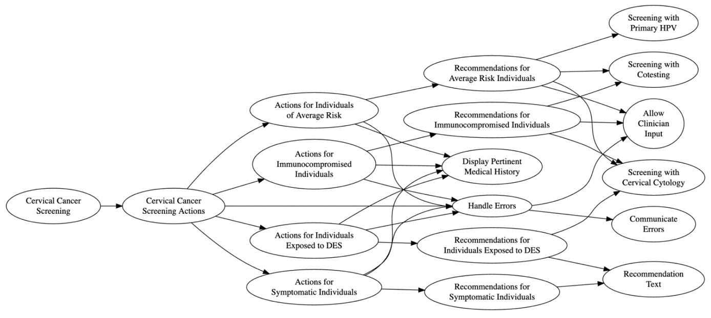

Figure 5. Diagram of Screening CDS

### Management CDS

The Management CDS implements recommendations for patients with abnormal cervical cancer screening results; it aligns with the L2 CDS component described in Section 4.1.5. As with the Screening CDS, the Management CDS provides recommendations for several populations of patients. Here, the populations are defined by the type of abnormality (e.g., common vs. rare) as well as the patient’s screening and treatment history. As shown in Figure 6, while each population is handled differently, recommendations typically result in suggested requests for one or more of the following interventions: surveillance with follow-up HPV testing (with or without cytology), colposcopy, or treatment. As with the Screening CDS, the clinician always has the option of providing additional information to the CDS; errors are also handled similarly.

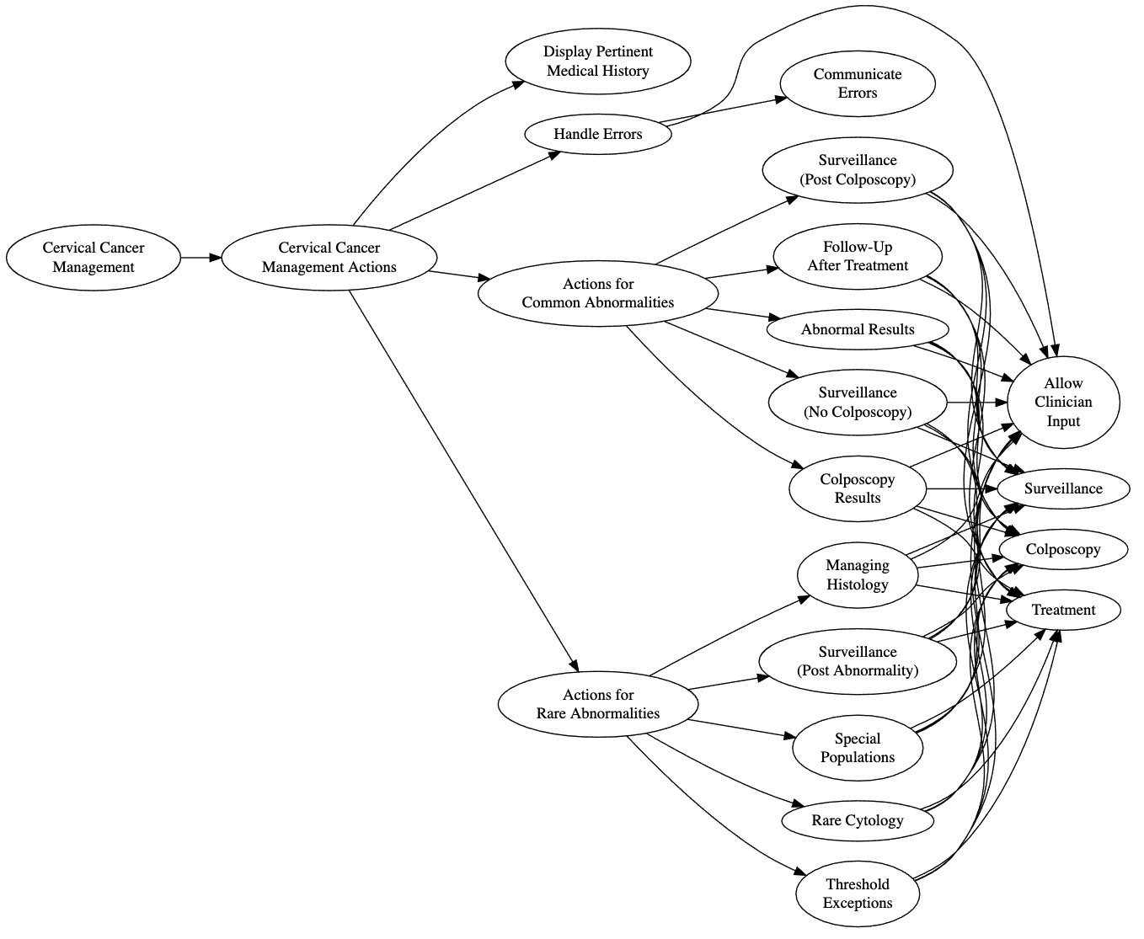

Figure 6. Diagram of Management CDS

## CDS Logic via CQL

While FHIR allows the structure of the CCSM CDS to be described, it can only enumerate the set of all actions that *could* apply to any patient. The CQL standard allows CDS logic to be expressed so that it can be determined which actions apply to a *specific* patient. As described in Section 5.1.4, CQL allows the CCSM CDS logic to be written as computer code that implements the following capabilities:

* Query patient electronic health record (EHR) for pertinent medical history
* Aggregate and sort pertinent medical history for presentation to the clinician on a dashboard
* Apply inclusion and exclusion logic to determine what actions of the CDS should apply to a particular patient
* Generate structured recommendations for the patient when appropriate
* Identify errors and communicate them to the clinician via meaningful notifications

## Conceptual CDS Usage

The following section describes at a high level how the CCSM CDS is meant to be used in practice. The discussion here is notional and informed by both the FHIR CRM as well as the CPG on FHIR IG. Implementation details are not considered; see Sections 6 and 7 for information about the software needed to implement the CDS for practical usage.

### FHIR $apply Operation

As described in previous sections, the structure of the CCSM CDS is defined by a set of FHIR resources. The structural FHIR resources primarily include PlanDefinition [32] and ActivityDefinition [33]; these resources come from the CRM and describe actions or groups of actions that are general and patient agnostic (that is, they have not been customized for any particular patient). The CRM provides an operation called “$apply,” which transforms these patient-agnostic resources into other FHIR resources which are customized for a particular patient [32], [33]. This is accomplished by evaluating CDS logic, expressed using CQL, in the context of the patient electronical health record. Figure 7 below illustrates the process behind the $apply operation; two notional examples are provided in the following section.

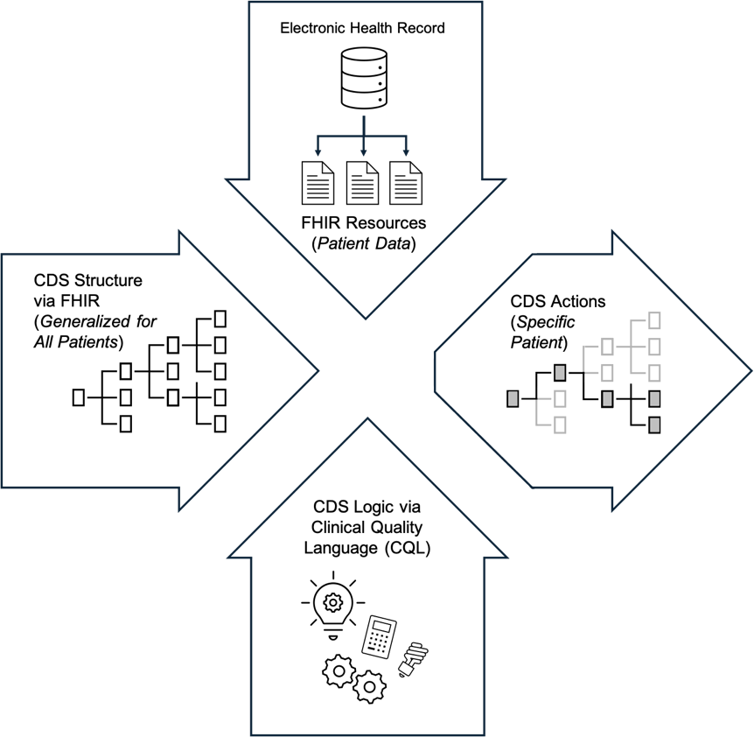

Figure 7. Illustration of the FHIR $apply operation

### Examples

The following two notional examples have been provided to better illustrate the process of using the CCSM CDS with the FHIR $apply operation.

#### Average-risk Risk Individual

Consider an individual who is considered average risk for cervical cancer. They come in for their wellness visit and the Screening CDS triggers when their patient chart is opened by the clinician. The Screening CDS correctly determines that the patient meets the inclusion criteria for being average risk and proceeds to generate a summary of their pertinent medical history; it also determines that the patient is due for their next cervical cancer screening. The clinician views this information and is presented with the option to order one of the recommended screening tests. There is also the option for the clinician to provide any information that they believe to be missing from the summary. Providing any new information may cause the Screening CDS to update its recommendation. Figure 8 below illustrates this notional example by taking the screening diagram from Figure 5 and highlighting the nodes which would be expected to be activated by the $apply operation.

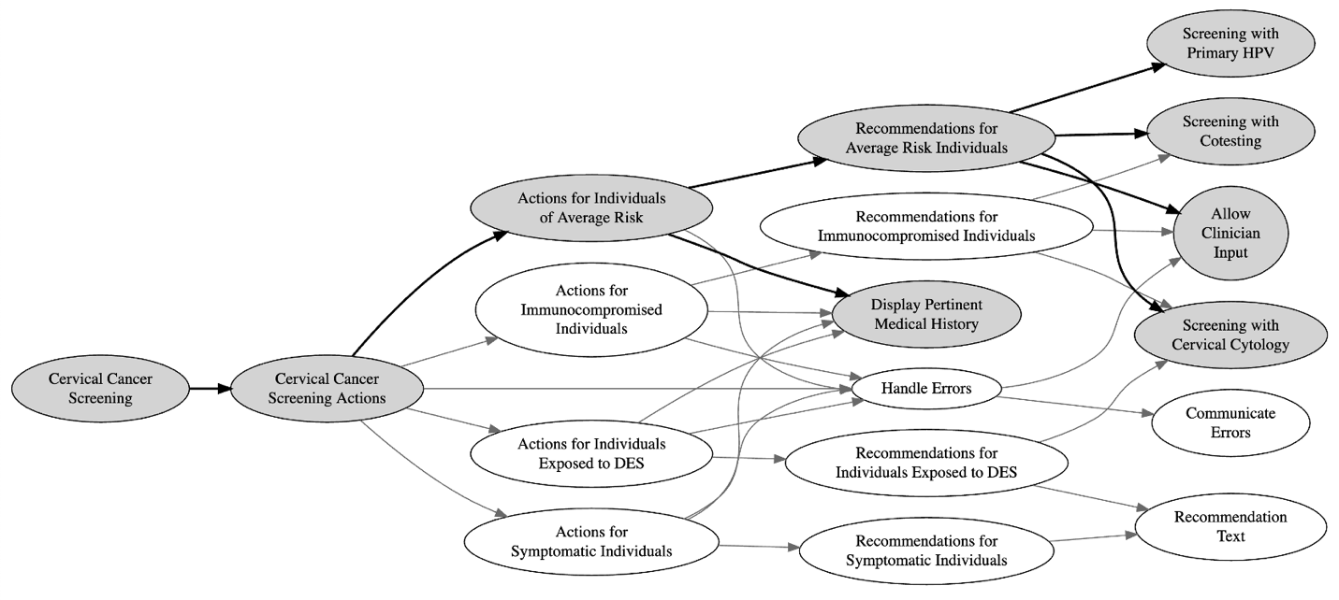

Figure 8. Notional $apply example (screening for average risk individual)

#### Immunocompromised Individual with Errors in EHR

Consider an individual with a compromised immune system. They come in for their wellness visit and the Screening CDS triggers when their patient chart is opened by the clinician. The Screening CDS correctly determines that the patient meets the immunocompromised inclusion criteria, however, it also detects discrepancies in the patient’s electronic health record. Because of the nature of these discrepancies, the CDS does not make any specific recommendations for the patient. The clinician is still able to view the summary of the medical history as well as a clearly worded error message indicating the nature of the problem. If the clinician knows the correct information which can resolve the discrepancies, they can provide it to the CDS via an electronic form. Providing any new information may cause the Screening CDS to update its recommendation. Figure 9 below illustrates this notional example by taking the screening diagram from Figure 5 and highlighting the nodes which would be expected to be activated by the $apply operation.

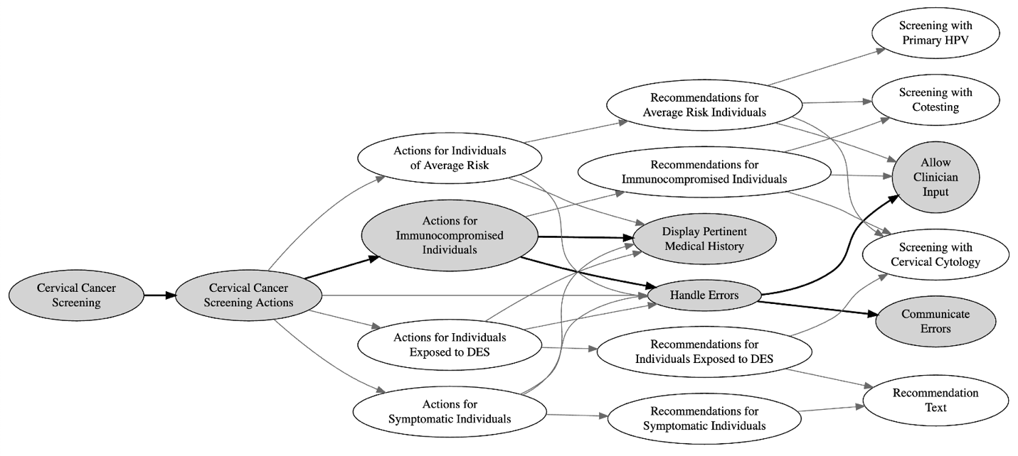

Figure 9. Notional $apply example (screening for immunocompromised individual with EHR errors)

## CDS L3 Source Code

The L3 CDS definitions have been released under an Apache 2.0 open-source license [36] and are available online in a version-controlled repository [37]. The Apache 2.0 license was chosen for the L3 CDS because it is generally considered to be permissive and friendly to commercial reuse of the software being licensed. Releasing the L3 CDS definitions under an Apache 2.0 license means that it can be freely incorporated into other software and systems, which can in turn be redistributed to others without permission from the L3 CDS authors. Conditions of the Apache 2.0 license include attribution requirements and lack of liability and/or warranty.

# CDS Testing & Validation

Testing is a critical step in the CDS development process; it is necessary to test a CDS to ensure that it faithfully implements the clinical logic as intended by the underlying guidelines. CDS testing follows an approach similar to what is used for testing computer software. This should come as no surprise since CDS can be thought of as a very specialized computer program. The following section outlines the testing methodology that has been used with the CCSM CDS. The role of testing in CDS development is first described and then the different types of testing are discussed. This section closes with a listing of the computer software tools used as part of the CCSM CDS testing process.

## Test Driven Development (TDD)

The CCSM CDS has been developed using what is known in the computer software domain as test driven development (TDD) [38]. With TDD, test cases are first created before any CDS software (“code”) is written. Each test case consists of a set of synthetic patient health data represented as FHIR resources as well as a specification for what the CDS outputs are expected to be. Once a test case is created, just enough CDS code is written so that the test passes (meaning the CDS outputs agree with the expected values). If a test case fails, the CDS code must be updated until the test case passes. This process of defining a test case and then writing a portion or “unit” of the CDS software continues until the code is deemed to be complete. The rationale for TDD is that it is expected that the resulting computer code will have fewer defects (“bugs”) than would normally exist in comparable software. Figure 10 shows a diagram depicting the test-driven approach used for developing the CCSM CDS. Section 6.2.2 discusses additional details regarding how test cases are determined.

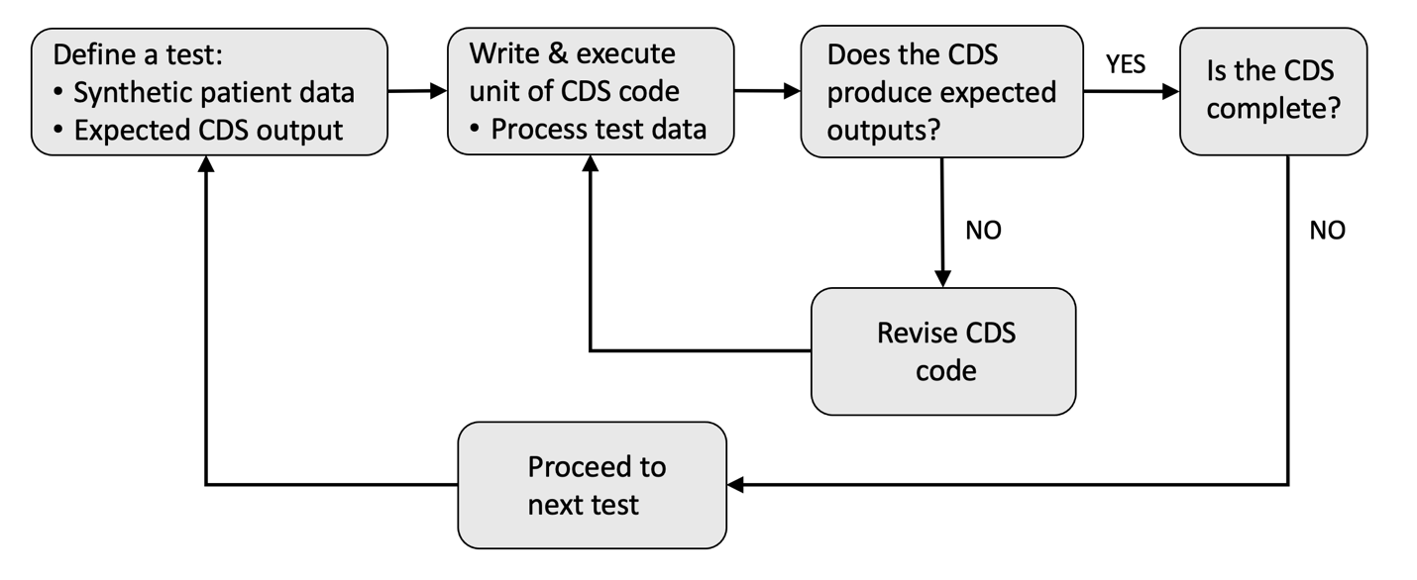

Figure 10. Illustration of test-driven approach for developing the CCSM CDS.

## Types of Testing

This section discusses the different types of testing used while the CCSM CDS has been developed. The types of tests start with simple formatting checks, progress to tests on the individual units of CDS logic, and finally conclude with the most representative type of testing which involves running the CDS software “end-to-end.” Each type of testing requires different supporting software tools, which are described in detail in Section 6.3.

### Specification Testing

Specification testing involves checking the CDS definition files to ensure they conform to the underlying specification(s). In the case of FHIR resources used to define the structure of the CDS, this entails checking that each are valid according to the FHIR specification. For CDS logic encoded using CQL, this means checking them for conformance with the CQL specification. The tools used for specification testing are described in Section 6.3.

Specification testing is important because it ensures that the CDS definitions actually are represented using interoperable standards. If the CCSM CDS definitions were to fail specification testing, it would mean they are not truly interoperable. Conversely, just because specification tests pass doesn’t mean that the CCSM CDS definitions are a valid representation of the underlying clinical guidelines and evidence. To check that, a different type of testing is needed.

### Unit Testing with Test Cases

CDS, as with most software, is comprised of small portions of computer code that are frequently referred to as “units.” Ideally, each unit is responsible for a single piece of CDS functionality (*e.g.*, a query for a specific type of patient electronic health information). As mentioned in the previous section, each unit of CQL logic must be verified to be valid according to the CQL specification. Once that has been verified, the *functionality* of the unit of CDS logic must be tested. This is accomplished by defining one or more test cases, as described in Section 6.1. The process of applying these test cases to computer code is called “unit testing.”

Each test case consists of synthetic electronic health records for a hypothetical patient as well as the corresponding expected CDS outputs. The synthetic electronic health records are specified with a set of FHIR resources while the expected CDS outputs are specified using knowledge of the underlying guidelines and on the L2 CDS. Unit testing involves running or “executing” the CQL code against the synthetic FHIR data and then comparing the output against the expected results. A unit of CQL code is not complete until all test cases referencing it pass successfully.

As of the writing of this document, over 1000 test cases have been created during the development of the CCSM CDS. These test cases are listed in Table 1 - Table 9 and have been derived from the underlying guidelines and the L2 CDS. The test cases focusing on management of abnormal screening results can be found in Table 5 - Table 9; these test cases align with the risk tables for common abnormalities produced by the National Cancer Institute (NCI) [14]. Additional test cases are being developed for rare abnormalities and special populations. All test cases are being published online alongside the L3 CDS definitions [37].

The descriptive test names listed in the first column of Table 1 - Table 9 follow a convention of “*Patient History – Intervention*,” where “*Patient History*” provides a very brief description of the patient’s screening history while “*Intervention*” lists the intervention recommended by the guidelines. The naming convention for the test cases can best be explained by example. Consider the nineth row in Table 6, which lists the following descriptive test name: “*Negative HPV ASCUS Then Negative HPV – Colposcopy*.” This name indicates a patient who had been previously screened with a cotest and received a negative HPV test result and a cytology result of ASCUS. On the subsequent screening test, they received another negative HPV test result which, according to the management guidelines, indicates that a colposcopy is recommended.

The number of cases listed in second column of Table 1 - Table 9 indicate how many individual test cases are associated with each descriptive test name. In the example from row nine of Table 6, there are three distinct test cases associated with the descriptive test name. Each test case corresponds to a different cytology result that accompanies the second negative HPV test result. Not every possible cytology result would result in a recommendation for a colposcopy. Only cytology corresponding to ASC-H, AGC, or HSIL would align with the recommendation and thus constitute the three test cases for this row. A complete description of all the tests cases can be found online [37]; the software for running the unit tests is also freely available and is described in Section 6.3.

### End-to-End Testing

Even once all units of CQL logic have been individually tested, they still must be tested *together* in a representative context. This is accomplished by executing the process described in Section 5.4.1 regarding the FHIR $apply operation. End-to-End Testing entails generating synthetic electronic health records for a hypothetical patient, processing that synthetic data using the CCSM CQL code, and using the CQL logical outputs to customize the CCSM PlanDefinition and other FHIR resources. The end result of the FHIR $apply operation is a set of FHIR resources which describe the CCSM CDS recommended actions and interventions. Once produced, these outputs can be evaluated for accuracy.

While the End-to-End Testing process may sound similar to the process used for Unit Testing, it additionally entails using the CCSM FHIR and CQL files together in concert. Also, the amount and complexity of the synthetic data is greater with End-to-End Testing and outputs typically have to be evaluated manually. These distinctions necessitate different and more complex software tools to help facilitate End-to-End Testing. Testing software is discussed in the next section.

## Testing Support Tools

Numerous software tools have been developed or leveraged to help support testing of the CCSM CDS. This section describes these software tools and discuss how they are used to support CDS testing. Many of these software tools could also be used with an initial implementation of the CCSM CDS (see Section 7).

### FHIR Validator

The FHIR Validator is a software program written in the Java programming language and maintained by HL7 [39]. It is capable of checking FHIR resource instances to ensure they adhere to the FHIR specification. The FHIR Validator can identify errors such as misspelled element names, missing or extraneous elements, and value formatting issues. It is run manually and generates a textual report summarizing all validation errors and warnings. The FHIR resources developed for the CCSM have been checked for errors using the FHIR Validator.

### CQL-to-ELM Translator

Recall from Section 5.1.4 that the human readable version of CQL must be converted or translated to the computer friendly format (i.e., ELM) before it can be used as a part of CDS software. The CQL-to-ELM Translator Reference Implementation is an open source software package written in the Java programming language [40]. It has been used to translate the CCSM CDS CQL, which as a by-product checks the CQL for conformance to the CQL specification. As with the FHIR Validator, this tool checks to make sure what has been written is, from a software standpoint, “grammatically correct.” It does not provide any insight into whether the CQL code, as written, correctly implements the intended CDS logic.

### CQL Execution Tools

Once CQL code has been translated into a computer friendly format, it additionally needs software to “execute” or “run” the result in the context of a patient’s electronic health record. Executing CQL in this way is necessary to support both Unit and End-to-End Testing. Multiple open-source CQL “execution engines” exist; the CCSM CDS has been unit tested using the CQL Execution Framework Reference Implementation, a software library written in the JavaScript programming language [41]. Additional JavaScript libraries are used to help interface with FHIR data [42] and to handle clinical codes and value sets [43]. For End-to-End Testing, an asynchronous library called CQL Workers is used for computational speed reasons [44].

### CQL Testing Framework

The CQL Testing Framework is a JavaScript software library that facilitates Unit Testing of CQL code [45]. While leveraging the CQL Execution Framework Reference Implementation, it provides a convenient short-hand notation for defining test cases. The CQL Testing Framework also automates the process of running the test cases, which greatly increases the efficiency of TDD of CDS. All Unit Tests listed in Table 1 through Table 5 were developed through the use of the CQL Testing Framework. The complete specifications for all test cases have been released under an open-source license and can be found online [46].

### Synthea

While the CQL Testing Framework allows simple test cases to be easily defined, it is less well suited for defining large numbers of test cases or complex test cases. Synthea is a mature open source tool for simulating large amounts of synthetic health record data [47]. It has the option of outputting data as FHIR resources, which makes it suitable for use with testing interoperable CDS. For Synthea to be able to generate suitable CCSM data, a cervical cancer “disease module” must be first defined [48]. A Synthea disease module is a directed graph that defines what types of health data must be simulated and the dependencies or constraints placed on that data. An initial cervical cancer disease module has been developed to support CCSM development and testing activities; it may be published in the future as part of a Synthea software update.

### Encender

Encender is a software library written in the JavaScript programming language that implements the FHIR $apply operation [49]. It has been developed for the specific purpose of testing the CCSM CDS but is also general in that it can be used with other CDS. The name “Encender,” which is also the Spanish word for “to light or turn on,” was chosen because the software allows FHIR resources representing CDS to be applied to a specific patient’s electronic health data. As shown in Figure 7 and discussed in Section 5.4, the output from the FHIR $apply operation, and thus the Encender library, includes the CDS recommended actions for a specific patient. This makes Encender a critical tool for End-to-End Testing; it uses the CQL Workers library for CQL code execution. Encender has been released as open source software [49].

### CCSM Dashboard Prototype

End-to-End Testing should be conducted in a representative testing environment. For the CCSM CDS, this includes displaying the CDS outputs in some sort of dashboard akin to the conceptual depiction shown in Figure 3. A prototype CCSM dashboard has been developed for testing purposes and will be made available as open source software. The CCSM Prototype Dashboard not only facilitates End-to-End Testing by making it easier to evaluate the accuracy of CDS outputs, but it also serves as a potential starting point for any clinical pilot or EHR integration of the CCSM CDS.

# CDS Integration

Integration refers to the process of incorporating a CDS for use within a health IT system; it can occur any time after initial CDS testing has concluded. This section outlines a process for integrating the CCSM CDS. It starts with a description of the health IT interoperability standards needed for integration. These standards provide multiple options for how the CCSM CDS can be integrated into a health IT system. Those options are discussed as are the high-level requirements for what a health IT system needs to provide in order to support integration. A necessary CDS integration activity called “data mapping” is described next. This CDS Integration concludes with a listing of strategies for handling unstructured data which the CCSM CDS may need to have access to.

## Interoperability Standards for CDS Integration

The interoperability standards described in Section 5.1 have been used to define the CCSM CDS in an open and shareable format. This section describes additional standards which aim to help support CDS integration into a health IT system.

### Sustainable Medical Applications, Reusable Technologies (SMART®)

The Sustainable Medical Applications, Reusable Technologies (SMART®) standard facilitates the integration of software applications, or “apps,” with health IT systems [50]. “SMART on FHIR apps,” or sometimes simply “SMART apps,” are software applications that securely interact with patient EHRs and other healthcare-related data via a FHIR API. SMART apps are interoperable in the sense that they can interface with any health IT system that supports the SMART standard and the data requirements of the app. Instead of writing a separate software application to provide the same capability for each different health IT system, a single application can be written that works with many different health IT systems.

A key component of SMART has been documented in the SMART App Launch IG [51]. It is the sequence of steps taken so that an app can be authenticated and authorized by a health IT system before any FHIR resources are accessed. This SMART App Launch Framework helps to ensure that a particular SMART app is granted access to only the EHR data that it needs and that its user is authorized to access. Some of the CCSM CDS integration options presuppose that SMART will be available in the system to which it is to be integrated. Without SMART, a custom interface would have to be designed for each health IT system, which defeats the intent and benefit of interoperable CDS. Fortunately, SMART has been specifically called out as a requirement for certified EHRs in the ONC 21st Century Cures Act Final Rule [50]. Many EHR vendors already support SMART [52], [53], [54].

### CDS Hooks

The CDS Hooks standard describes how CDS services, which are simply software that provide CDS, can be integrated with health IT systems [55]. While SMART is more general in nature, CDS Hooks focuses on integrating CDS into the clinician workflow. This is accomplished through the use of a number of so-called “hooks,” which is a software term for a technique for altering the behavior of a software program [56]. CDS Hooks focuses on how CDS recommendations can be sent to a health IT system via informational “cards.” In contrast with SMART, a CDS Hooks integration would typically assume that some other system (*e.g.*, the health IT system) would be responsible for displaying the information in these cards to the clinician. This distinction is discussed further in the next section.

## Integration Options

This section describes three integration options for the CCSM CDS using SMART and/or CDS Hooks. These options are based upon the different approaches taken by SMART and CDS Hooks, as depicted below in Figure 11, for integrating CDS into a health IT system. With the SMART on FHIR approach, the CDS application is typically responsible for displaying any content and recommendations to the user. With CDS Hooks, that content and recommendations are typically sent back to the health IT system, which is then responsible for displaying it.

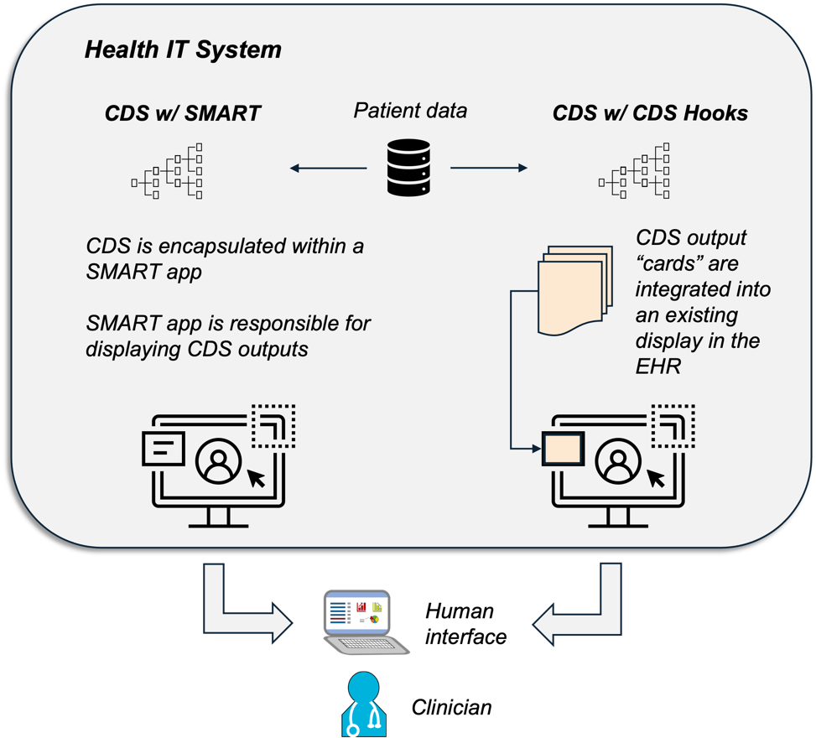

Figure 11. Diagram showing integration approaches taken by SMART and CDS Hooks.

### Option 1: SMART

The first integration option entails embedding the CCSM CDS into a standalone SMART on FHIR application. The SMART application can be launched from the health IT system but must then query the EHR for the patient data required by the CDS. Once the required data has been pulled from the EHR, it is used along with the CDS definition as part of the FHIR $apply operation (see Section 5.4.1). The outputs from the FHIR $apply operation are then used to populate the CCSM dashboard and present the clinician with recommendations. If the clinician chooses to act on the recommendations, the SMART application must transmit the confirmed intervention back to the EHR.

The benefits of this integration option include the fact that the CDS is entirely self-contained and has control over the presentation of the CDS outputs. The drawbacks of this integration option include the fact that the clinician has to “leave” the native health IT system in order to interact with the CDS. Also, all CDS software must be bundled within a single application, which may be computationally inefficient. Finally, if the SMART application containing the CDS is hosted apart from the health IT system, there may be latencies associated with data transfer which may impact the user experience.

### Option 2: CDS Hooks

The second integration option involves operating one or more CDS Hooks services which implement the CCSM CDS. As with the first integration option, patient data is accessed via a FHIR API. However, the results from evaluating the FHIR $apply operation are returned back to the health IT system which triggered the CDS. These CDS outputs are returned in the form of one or more cards, which are just a standardized format defined by CDS Hooks. The health IT system is responsible for presenting the output cards to the user.

One advantage of a purely CDS Hooks approach is that the CDS outputs can be integrated more naturally into the health IT system display. This may help users become more comfortable with using the CDS. Additionally, the user does not have to “leave” the health IT system to use the CDS, which has both user experience as well as latency benefits. Finally, the second integration option provides better flexibility in terms of how the CDS software is structured. The main disadvantage of the second integration option is that there little to no control over how the CDS outputs are displayed to the user. Also, interactive CDS (user provides inputs after the CDS initially triggers) may be harder to implement with a purely CDS Hooks approach.

### Option 3: CDS Hooks and SMART

The third integration option involves combining the CDS Hooks and SMART approaches. The initial CDS trigger and inclusion logic is handled via a CDS Hooks service, which returns a card to the health IT system containing a link to a SMART app. This SMART app is responsible for part of the CDS logic as well as displaying the CDS outputs to the user. The third integration option has many of the advantages and disadvantages of the first two options, with the additional disadvantage of being more complex to implement. The third integration option would be appealing to implementors that already have a CDS Hooks capability but want to have more flexibility with how interaction with the user is handled.

## Requirements

This section provides some high-level requirements for integration of the CCSM CDS into a health IT system. Functional requirements are discussed first, followed by data requirements.

### Functional Requirements

A health IT system for which the CCSM CDS will be integrated must support the following capabilities:

1. Read access of required patient data via FHIR API (see Section 7.3.2)
2. Write access via FHIR API (outputs of $apply operation)
3. SMART app launch (if using integration options #1 or #3)
4. CDS Hooks services (if using integration options #2 or #3)
5. FHIR $apply operation
6. CQL execution capabilities

The last two requirements may be fulfilled with the help of the testing software listed in Section 6.3. There are other open sources tools which may help address the other requirements.

### Data Requirements

The CCSM CDS must by definition make certain assumptions about what data will be available in the patient EHR. These assumptions are represented by a set of data requirements consisting of the type of data required, how that data will be represented using FHIR, and what clinical informatic code(s) will be used. The data requirements are defined by the FHIR queries performed within the CQL logic of the CCSM CDS. Appendix B provides a high-level overview of the CCSM CDS data requirements.

## Data Mapping

It is expected that most health IT systems will not meet all data requirements discussed in Section 7.3.2. Data mapping is the process of transforming some or all of the data in a health IT system such that the data requirements of the CDS are satisfied. Data mapping can be the most time-consuming aspect of CDS integration; it is recommended that both clinical and technical resources be available to support it. Without a proper data mapping, the CDS may fail to locate all the patient data necessary for proper operation.

For health IT systems without a FHIR API, the first step in data mapping would be implementing a FHIR API that is accessible to the CDS. For health IT systems with an existing FHIR API, there may some types of FHIR resources which are needed by the CDS but that are not supported by the API. In this case, the next step would be to add support for the missing FHIR resource types, either by directly augmenting the FHIR API or via an additional “interoperability layer.” Finally, the health IT system’s FHIR API may support all necessary FHIR resources, but the FHIR resources may not use the same clinical codes employed by the CDS. In this case, the codes used in the health IT system must be converted, or “mapped,” to the codes assumed by the CDS.

## Handling Unstructured Data

Despite best efforts through data mapping, there may still be information needed by the CCSM CDS which will not have the required structure as FHIR resources. This section describes approaches for handling so-called unstructured data, which can include information from anatomic pathology laboratory systems.

### Allow Clinician Input

A key aspect of the CCSM CDS is to, when necessary, allow clinicians to provide input to augment the information in the patient EHR. Clinician input is captured using a FHIR Questionnaire resource, which allows a structured set of questions and available responses to be represented in a standard format [57]. The FHIR Questionnaire is being developed in conjunction with the CCSM CDS and initially includes the three questions listed in Table 10. The advantage of this approach is that it allows clinician judgement to be leveraged and incorporated into the CCSM CDS logic when information in the patient EHR is lacking. The disadvantage of this approach is that it requires additional time and effort from the clinician.

### A Natural Language Processing (NLP) Application Programming Interface (API)

Natural Language Processing, or NLP, is a technology that among other things attempts to extract knowledge from unstructured or textual narrative data. NLP has been applied to a number of areas in the healthcare domain, including interpretation of anatomic pathology laboratory reports such as cervical cytology reports. This section describes an approach for allowing information from existing NLP algorithms to be incorporated into the CCSM CDS.

CDS Hooks provides a mechanism in which outputs from existing NLP algorithms can be leveraged by the CCSM CDS. A CDS Hooks service can be setup which would trigger when new unstructured data is created in the EHR. The data would be wrapped in a FHIR resource and sent via a CDS Hooks API to the NLP service. The data would be unpacked and processed by the NLP algorithm; CDS Hooks and the FHIR CRM provide a process by which the NLP outputs can be ingested back into the EHR as FHIR resources. This can be done in such a way that the CCSM CDS can accurately leverage the knowledge provided by the NLP algorithm.

# References

|  |  |
| --- | --- |
| [1] | HL7, "Fast Healthcare Interoperability Resources (FHIR)," [Online]. Available: http://hl7.org/fhir/. [Accessed 5 August 2020]. |
| [2] | HL7, "CQL - Introduction - Background," 23 June 2019. [Online]. Available: https://cql.hl7.org/01-introduction.html#background. |
| [3] | Centers for Disease Control and Prevention, "Cervical Cancer Statistics," 8 June 2021. [Online]. Available: https://www.cdc.gov/cancer/cervical/statistics/index.htm. [Accessed 1 October 2021]. |
| [4] | (CDC), Centers for Disease Control and Prevention, "Cervical Cancer Statistics," 8 June 2021. [Online]. Available: https://www.cdc.gov/cancer/cervical/statistics/index.htm. [Accessed 29 July 2021]. |
| [5] | R. Nayar, R. A. Goulart and D. D. Davey, "Primary HPV cervical cancer screening in theUnited States: Are we ready?," *Journal of the American Society of Cytopathology,* vol. 7, pp. 50-55, 2018. |
| [6] | American College of Obstetricians and Gynecologists, "Updated Cervical Cancer Screening Guidelines," April 2021. [Online]. Available: https://www.acog.org/clinical/clinical-guidance/practice-advisory/articles/2021/04/updated-cervical-cancer-screening-guidelines. [Accessed July 2021]. |
| [7] | R. B. Perkins, R. S. Guido, P. E. Castle, D. Chelmow, M. H. Einstein, F. Garcia, W. K. Huh, J. J. Kim, A.-B. Moscicki, R. Nayar, M. Saraiya, G. F. Sawaya, N. Wentzensen and M. Schiffman, "2019 ASCCP Risk-Based Management Consensus Guidelines for Abnormal Cervical Cancer Screening Tests and Cancer Precursors," *Journal of Lower Genital Tract Disease,* vol. 24, no. 2, pp. 102-131, 2020. |
| [8] | National Cancer Institute Staff, "ACS’s Updated Cervical Cancer Screening Guidelines Explained," 18 September 2020. [Online]. Available: https://www.cancer.gov/news-events/cancer-currents-blog/2020/cervical-cancer-screening-hpv-test-guideline. [Accessed 1 October 2021]. |
| [9] | W. B. Freeman HP, "Excess Cervical Cancer Mortality: A Marker for Low Access to Health Care in Poor Communities," National Cancer Institute, Center to Reduce Cancer Health Disparities, 2005. |
| [10] | Centers for Disease Control and Prevention, "Adapting Clinical Guidelines for the Digital Age Initiative," [Online]. Available: https://www.cdc.gov/ddphss/clinical-guidelines/index.html. |
| [11] | Agency for Healthcare Research and Quality, "CDS Connect," [Online]. Available: https://cds.ahrq.gov/cdsconnect/about. |
| [12] | M. Michaels, *Adapting Clinical Guidelines for the Digital Age,* January 5, 2021. |
| [13] | United States Preventive Services Task Force, "Cervical Cancer: Screening," 21 August 2018. [Online]. Available: https://www.uspreventiveservicestaskforce.org/uspstf/recommendation/cervical-cancer-screening. |
| [14] | D. Egemen, L. C. Cheung, X. Chen, M. Demarco, R. B. Perkins, W. Kinney, N. Poitras, B. Befano, A. Locke, R. S. Guido, A. L. Wiser, J. C. Gage, H. A. Katki, N. Wentzensen, P. E. Castle, M. Schiffman and T. S. Lorey, "Risk Estimates Supporting the 2019 ASCCP Risk-Based Management Consensus Guidelines," *Journal of Lower Genital Tract Disease,* vol. 24, no. 2, pp. 132-143, 2020. |
| [15] | ASCCP Clinical Practice Statement, "Evaluation of the Cervix in Patients with Abnormal Vaginal Bleeding," 7 February 2017. [Online]. Available: https://www.asccp.org/Assets/9d92e617-858f-43f3-af62-44adf76cfc67/636220616039000000/vaginal-bleeding-statement-final-02-06-17-pdf. [Accessed July 2021]. |
| [16] | "Practice Bulletin No. 168: Cervical Cancer Screening and Prevention," *Obstetrics and Gynecology,* vol. 1284, no. 4, pp. e111-e130, 2016. |
| [17] | M. Rubin, "Antenatal exposure to DES: Lessons Learned...Future Concerns," *Obstetrical & Gynecological Survey,* vol. 62, no. 8, pp. 548-555, 2007. |
| [18] | Panel on Opportunistic Infections in Adults and Adolescents with HIV, "Guidelines for the prevention and treatment of opportunistic infections in adults and adolescents with HIV: Recommendations from the CDC, the NIH, and the HIV Medicine Association of the Infectious Diseases Society of America," 29 November 2018. [Online]. Available: https://clinicalinfo.hiv.gov/en/guidelines/adult-and-adolescent-opportunistic-infection/human-papillomavirus-disease. [Accessed July 2021]. |
| [19] | A.-B. Moscicki, L. Flowers, M. J. Huchko, M. E. Long, K. L. MacLaughlin, J. Murphy, L. B. Spiryda and M. A. Gold, "Guidelines for Cervical Cancer Screening in Immunosuppressed Women Without HIV Infection," *Journal of Lower Genital Tract Disease,* vol. 23, no. 2, pp. 87-101, 2019. |
| [20] | HL7, "FHIR Clinical Guidelines: CQF Recommendations," [Online]. Available: https://build.fhir.org/ig/HL7/cqf-recommendations/. |
| [21] | HL7, "FHIR: Resource Index," 1 November 2019. [Online]. Available: https://www.hl7.org/fhir/resourcelist.html. |
| [22] | HL7, "Condition," 1 November 2019. [Online]. Available: http://hl7.org/fhir/condition.html. |
| [23] | HL7, "Observation," 1 November 2019. [Online]. Available: http://hl7.org/fhir/observation.html. |
| [24] | HL7, "Extensibility," 1 November 2019. [Online]. Available: https://www.hl7.org/fhir/extensibility.html. |
| [25] | HL7, "Profiling FHIR," 1 November 2019. [Online]. Available: https://www.hl7.org/fhir/profiling.html. |
| [26] | The Office of the National Coordinator for Health Information Technology, "ONC's Cures Act Final Rule," [Online]. Available: https://www.healthit.gov/curesrule/. [Accessed 2 Sept 2021]. |
| [27] | Office of the National Coordinator for Health IT, "ONC's Cures Act Final Rule Highlighted Regulatory Dates," [Online]. Available: https://www.healthit.gov/curesrule/overview/oncs-cures-act-final-rule-highlighted-regulatory-dates. [Accessed 19 Jan 2022]. |
| [28] | HL7 International, "Clinical Reasoning Module," [Online]. Available: http://www.hl7.org/fhir/clinicalreasoning-module.html. [Accessed 02 Sept 2021]. |
| [29] | HL7 International, "Clinical Decision Support Services," [Online]. Available: http://www.hl7.org/fhir/clinicalreasoning-cds-on-fhir.html. [Accessed 02 Sept 2021]. |
| [30] | HL7, "FHIR Clinical Guidelines," 11 February 2021. [Online]. Available: http://hl7.org/fhir/uv/cpg/. |
| [31] | HL7, "FHIR Clinical Guidelines: Knowledge Representation," 11 February 2021. [Online]. Available: http://hl7.org/fhir/uv/cpg/documentation-approach-02-04-knowledge-representation.html. |
| [32] | HL7, "FHIR: PlanDefinition," 1 November 2019. [Online]. Available: https://www.hl7.org/fhir/plandefinition.html. |
| [33] | HL7, "FHIR: ActivityDefinition," 1 November 2019. [Online]. Available: https://www.hl7.org/fhir/activitydefinition.html. |
| [34] | HL7, "FHIR: Questionnaire," 1 November 2019. [Online]. Available: https://www.hl7.org/fhir/questionnaire.html. |
| [35] | HL7, "FHIR: Library," 1 November 2019. [Online]. Available: https://www.hl7.org/fhir/library.html. |
| [36] | The Apache Software Foundation, "Apache License, Version 2.0," [Online]. Available: https://www.apache.org/licenses/LICENSE-2.0. [Accessed 19 Jan 2022]. |
| [37] | GitHub, "CCSM CDS and Tests," [Online]. Available: https://github.com/ccsm-cds-tools/ccsm-cds-with-tests. [Accessed 28 September 2021]. |
| [38] | Wikipedia, "Test driven development," [Online]. Available: https://en.wikipedia.org/wiki/Test-driven_development. [Accessed 02 Sept 2021]. |
| [39] | HL7 International, "FHIR Validation," [Online]. Available: https://www.hl7.org/fhir/validation.html. [Accessed 02 Sept 2021]. |
| [40] | "CQL-to-ELM Translator Reference Implementation," [Online]. Available: https://github.com/cqframework/clinical_quality_language/blob/master/Src/java/cql-to-elm/OVERVIEW.md. [Accessed 02 Sept 2021]. |
| [41] | Clinical Quality Framework, "CQL Execution Framework," [Online]. Available: https://github.com/cqframework/cql-execution. [Accessed 5 August 2020]. |
| [42] | Clinical Quality Framework, "cql-exec-fhir," [Online]. Available: https://github.com/cqframework/cql-exec-fhir. [Accessed 02 Sept 2021]. |
| [43] | Clinical Quality Framework, "cql-exec-vsac," [Online]. Available: https://github.com/cqframework/cql-exec-vsac. [Accessed 02 Sept 2021]. |
| [44] | ASBI CDS Tools, "CQL Worker," [Online]. Available: https://github.com/asbi-cds-tools/cql-worker. [Accessed 02 Sept 2021]. |
| [45] | Agency for Healthcare Research and Quality, "CQL Testing Framework," [Online]. Available: https://github.com/asbi-cds-tools/cql-worker. [Accessed 02 Sept 2021]. |
| [46] | GitHub, "CCSM Tests," [Online]. Available: https://github.com/ccsm-cds-tools/ccsm-cds-with-tests/tree/main/test. [Accessed 28 September 2021]. |
| [47] | The Standard Health Collaborative, "Synthea: Synthetic Patient Generation," [Online]. Available: https://synthetichealth.github.io/synthea/. [Accessed 02 Sept 2021]. |
| [48] | The MITRE Corporation, "The technology behind patient simulation," [Online]. Available: https://synthetichealth.github.io/synthea/#technology-landing. [Accessed 31 Jan 2022]. |
| [49] | GitHub, "Encender," [Online]. Available: https://github.com/ccsm-cds-tools/encender. [Accessed 28 September 2021]. |
| [50] | Computational Health Informatics Program, "SMART," [Online]. Available: https://smarthealthit.org/. [Accessed 02 Sept 2021]. |
| [51] | HL7 International, "SMART App Launch Framework," [Online]. Available: http://hl7.org/fhir/smart-app-launch/index.html. [Accessed 02 Sept 2021]. |
| [52] | Epic, "EHR Launch (SMART on FHIR)," [Online]. Available: https://fhir.epic.com/Documentation?docId=oauth2&section=EmbeddedOauth2Launch. [Accessed 2022 Jan 2022]. |
| [53] | Cerner, "SMART," [Online]. Available: https://fhir.cerner.com/smart/. [Accessed 31 Jan 2022]. |
| [54] | Allscripts, "SMART on FHIR," [Online]. Available: https://developer.allscripts.com/content/fhir/content/smart%20on%20fhir/. [Accessed 31 Jan 2022]. |
| [55] | HL7 & Boston Children's Hospital, "CDS Hooks," [Online]. Available: https://cds-hooks.org/. [Accessed 02 Sept 2021]. |
| [56] | Wikipedia, "Hooking," [Online]. Available: https://en.wikipedia.org/wiki/Hooking. [Accessed 02 Sept 2021]. |
| [57] | HL7 International, "Questionnaire Resource," [Online]. Available: https://www.hl7.org/fhir/questionnaire.html. [Accessed 28 September 2021]. |
| [58] | HL7, "Elements," 1 November 2019. [Online]. Available: https://www.hl7.org/fhir/element.html. |
| [59] | HL7, "Patient.name," 1 November 2019. [Online]. Available: https://www.hl7.org/fhir/patient-definitions.html#Patient.name. |
| [60] | HL7, "Patient," 1 November 2019. [Online]. Available: https://www.hl7.org/fhir/patient.html. |
| [61] | HL7, "US Core BirthSex Extension," 6 November 2019. [Online]. Available: https://www.hl7.org/fhir/us/core/StructureDefinition-us-core-birthsex.html. |
| [62] | The Office of the National Coordinator for Health Information Technology, "Representing Patient Sex (At Birth)," [Online]. Available: https://www.healthit.gov/isa/representing-patient-sex-birth. [Accessed 5 August 2020]. |
| [63] | HL7, "U.S. Core Pediatric BMI for Age Profile," 6 November 2019. [Online]. Available: http://hl7.org/fhir/us/core/StructureDefinition-pediatric-bmi-for-age.html. |
| [64] | HL7, "Computable Plan Definition," 11 February 2021. [Online]. Available: http://hl7.org/fhir/uv/cpg/StructureDefinition-cpg-computableplandefinition.html. |
| [65] | HL7, "PlanDefinition," 1 November 2019. [Online]. Available: https://www.hl7.org/fhir/plandefinition.html. |
| [66] | HL7, "FHIR Clinical Guidelines: Computable Plan Definition," 11 February 2021. [Online]. Available: http://hl7.org/fhir/uv/cpg/StructureDefinition-cpg-computableplandefinition.html. |
| [67] | S. B. K. C. T. A. B. A. C. J. e. a. Schapira MM, "Inadequate Systems to Support Breast and Cervical Cancer Screening in Primary Care," *J Gen Intern Med,* vol. 31, no. 10, p. 1148–55, 2016. |

###### Lists of Test Cases

Table 1. Test Cases for Screening with Symptomatic Individuals

|  |  |
| --- | --- |
| Test Name (Screening with Symptomatic Individuals) | # Cases |
| Age 21 and under recommendation - Diagnostic exam | 4 |
| All inclusion criteria are met | 1 |
| NILM cytology and negative HPV test within last 3 years that reference the same encounter - Diagnostic exam | 4 |
| NILM cytology and negative HPV test within last 3 years that reference the same service request - Diagnostic exam | 4 |
| NILM cytology and negative HPV test within last 3 years - Diagnostic exam | 4 |
| NILM cytology within last 12 months - Diagnostic exam | 2 |
| Non-coincident NILM cytology and negative HPV test within last 3 years - Diagnostic exam | 4 |
| Visible cervical or vaginal lesions as observed by a clinician - Diagnostic exam | 12 |
| Total Number of Tests: Screening with Symptomatic Individuals | 35 |

Table 2. Test Cases for Screening with Individuals Exposed to DES

|  |  |
| --- | --- |
| Test Name (Screening with Individuals Exposed to DES) | # Cases |
| All inclusion criteria are met | 1 |
| Exclusion criteria met | 27 |
| Not included | 1 |
| One inclusion criteria is met | 3 |
| Total Number of Tests: Screening with Individuals Exposed to DES | 32 |

Table 3. Test Cases for Screening with Immunocompromised Individuals

|  |  |
| --- | --- |
| Test Name (Screening with Immunocompromised Individuals) | # Cases |
| All inclusion criteria are met | 1 |
| Completed 3 annual cytology tests | 8 |
| Need cytology test number 1 | 1 |
| Need cytology test number 2 | 2 |
| Need cytology test number 3 | 4 |
| ERROR Cotest With Missing HPV Result | 1 |
| ERROR Cotest With Non-Negative HPV Result | 1 |
| Excluded no cervix | 1 |
| Chronic graft-versus-host disease after bone marrow transplant | 1 |
| Chronic graft-versus-host disease without transplant | 1 |
| HIV diagnosis today | 1 |
| IBS or arthritis with immunosuppressant | 6 |
| One inclusion criteria from four years ago | 5 |
| Reset to cytology test 1 on first test | 2 |
| Reset to cytology test 1 on second test | 4 |
| Reset to cytology test 1 on third test | 8 |
| Under 21 and immunocompromised | 1 |
| Under 30 and need cytology test number 1 | 1 |
| Total Number of Tests: Screening with Immunocompromised Individuals | 49 |

Table 4. Test Cases for Screening with Individuals of Average Risk

|  |  |
| --- | --- |
| Test Name (Screening with Individuals of Average Risk) | # Cases |
| Age between 21 and 29 and have had recent cytology test | 5 |
| Age between 21 and 29 and have NOT had recent cytology test | 5 |
| Age between 21 and 29 and proposed date for cervical cytology in the future | 1 |
| Age between 21 and 29 and proposed date for cervical cytology today | 1 |
| Age between 30 and 65 and have had recent cytology test | 5 |
| Age between 30 and 65 and have had recent HPV test | 7 |
| Age between 30 and 65 and have NOT had recent cytology test | 5 |
| Age between 30 and 65 and have NOT had recent HPV test | 5 |
| Age between 30 and 65 and proposed date for cervical cytology in the future | 1 |
| Age between 30 and 65 and proposed date for cervical cytology today | 1 |
| Age between 30 and 65 and proposed date for HPV testing in in the future | 1 |
| Age between 30 and 65 and proposed date for HPV testing is today | 1 |
| Age between 30 and 65 with both HPV and Cytology tests | 1 |
| Eligible for Grade D Recommendation | 1 |
| Adequately screened per Grade D Recommendation | 1 |
| Grade D ERROR Missing Cytology Result Empty Conclusion Code | 1 |
| Grade D ERROR Missing Cytology Result Missing Conclusion Code | 1 |
| Grade D ERROR Missing HPV Result Empty Conclusion Code | 1 |
| Grade D ERROR Missing HPV Result Missing Conclusion Code | 1 |
| Grade D ERROR Unexpected Cytology Result | 1 |
| Grade D ERROR Unexpected HPV Result | 1 |
| Grade D Propose Cotest Now | 1 |
| Grade D Propose Cytology Now | 1 |
| Grade D Propose Future Cotest | 1 |
| Grade D Propose Future Cytology | 1 |
| Grade D Propose Future HPV Test | 1 |
| Grade D Propose HPV Test Now | 1 |
| Included female | 1 |
| Included transgender male | 1 |
| Patient Meets All Exclusion Criteria | 1 |
| Patient Meets One Exclusion Criteria | 3 |
| Patient with Cervix Removed | 1 |
| NILM cytology and negative HPV test within last 5 years from same day | 1 |
| NILM cytology and negative HPV test within last 5 years that reference the same encounter | 1 |
| NILM cytology and negative HPV test within last 5 years that reference the same service request | 1 |
| Total Number of Tests: Screening with Individuals of Average Risk | 63 |

Table 5. Test Cases for Management of Common Abnormalities (Risk Table 1: Screening)

| Test Name (Management of Common Abnormalities – Risk Table 1 – Screening) | # Cases |
| --- | --- |
| Negative Cotest Then Postive HPV16 - Colposcopy | 6 |
| Negative Cotest Then Postive HPV18 - Colposcopy | 6 |
| Negative Cotest Then Negative HPV - 3 Year Follow Up | 2 |
| Negative Cotest Then Negative HPV - 5 Year Follow Up | 2 |
| Negative Cotest Then Negative HPV - Colposcopy | 3 |
| Negative Cotest History Positive HPV - 1 Year Follow Up | 3 |
| Negative Cotest Then Positive HPV - Colposcopy | 2 |
| Negative Cotest Then Positive HPV - Colposcopy or Treatment | 1 |
| Negative HPV Then Postive HPV16 - Colposcopy | 6 |
| Negative HPV Then Postive HPV18 - Colposcopy | 6 |
| Negative HPV Then Negative HPV - 1 Year Follow Up | 1 |
| Negative HPV Then Negative HPV - 3 Year Follow Up | 1 |
| Negative HPV Then Negative HPV - 5 Year Follow Up | 2 |
| Negative HPV Then Negative HPV - Colposcopy | 3 |
| Negative HPV Then Positive HPV - 1 Year Follow Up | 3 |
| Negative HPV Then Positive HPV - Colposcopy | 2 |
| Negative HPV Then Positive HPV - Colposcopy or Treatment | 1 |
| No History Postive HPV16 - Colposcopy | 3 |
| No History Postive HPV16 - Colposcopy or Treatment | 2 |
| No History Postive HPV16 - Treatment | 1 |
| No History Postive HPV18 - Colposcopy or Treatment | 2 |
| No History Negative HPV - 1 Year Follow Up | 1 |
| No History Negative HPV - 3 Year Follow Up | 1 |
| No History Negative HPV - 5 Year Follow Up | 2 |
| No History Negative HPV - Colposcopy | 2 |
| No History Negative HPV - Colposcopy or Treatment | 1 |
| No History Positive HPV - 1 Year Follow Up | 1 |
| No History Positive HPV - Colposcopy | 2 |
| No History Positive HPV - Colposcopy or Treatment | 3 |
| Total Number of Tests: Management of Common Abnormalities – Risk Table 1 – Screening | **71** |

Table 6. Test Cases for Management of Common Abnormalities (Risk Table 2: Surveillance)

| Test Name (Management of Common Abnormalities – Risk Table 2 – Surveillance) | # Cases |
| --- | --- |
| Positive HPV NILM Then Negative Cotest Then Negative HPV - 3 Year Follow Up | 1 |
| Positive HPV NILM Then Negative Cotest Then Positive HPV - 1 Year Follow Up | 3 |
| Positive HPV NILM Then Negative Cotest Positive HPV - Colposcopy | 3 |
| Positive HPV NILM Then Negative HPV Then Negative HPV - 3 Year Follow Up | 6 |
| Positive HPV NILM Then Negative Positive HPV - 1 Year Follow Up | 3 |
| Positive HPV NILM Then Negative Positive HPV - Colposcopy | 3 |
| Negative HPV ASCUS Then Negative HPV - 1 Year Follow Up | 2 |
| Negative HPV ASCUS Then Negative HPV - 5 Year Follow Up | 1 |
| Negative HPV ASCUS Then Negative HPV - Colposcopy | 3 |
| Negative HPV ASCUS Then Positive HPV - 1 Year Follow Up | 3 |
| Negative HPV ASCUS Then Positive HPV - Colposcopy | 2 |
| Negative HPV ASCUS Then Positive HPV - Colposcopy or Treatment | 1 |
| Negative HPV LSIL Then Negative HPV - 1 Year Follow Up | 2 |
| Negative HPV LSIL Then Negative HPV - 3 Year Follow Up | 1 |
| Negative HPV LSIL Then Negative HPV - Colposcopy | 3 |
| Negative HPV LSIL Then Positive HPV - 1 Year Follow Up | 1 |
| Negative HPV LSIL Then Positive HPV - Colposcopy | 4 |
| Negative HPV LSIL Then Positive HPV - Colposcopy or Treatment | 1 |
| Positive HPV NILM Then Postive HPV16 - Colposcopy | 3 |
| Positive HPV NILM Then Postive HPV16 - Colposcopy or Treatment | 3 |
| Positive HPV NILM Then Postive HPV18 - Colposcopy | 3 |
| Positive HPV NILM Then Postive HPV18 - Colposcopy or Treatment | 3 |
| Positive HPV NILM Then Negative HPV - 1 Year Follow Up | 4 |
| Positive HPV NILM Then Negative HPV - Colposcopy | 2 |
| Positive HPV NILM Then Negative HPV - Colposcopy or Treatment | 1 |
| Positive HPV NILM Then Positive HPV - Colposcopy | 4 |
| Positive HPV NILM Then Positive HPV - Colposcopy or Treatment | 2 |
| Total Number of Tests: Management of Common Abnormalities – Risk Table 2 – Surveillance | **68** |

Table 7. Test Cases for Management of Common Abnormalities (Risk Table 3: Colposcopy Results)

| Test Name (Management of Common Abnormalities – Risk Table 3 – Colposcopy Results) | # Cases |
| --- | --- |
| AIS Biopsy - Treatment | 1 |
| Cancer Biopsy - Treatment | 1 |
| ASCH AGC or HSIL Then CIN1 Biopsy - 1 Year Follow Up | 3 |
| CIN2 Biopsy - Treatment | 1 |
| CIN3 Biopsy - Treatment | 1 |
| Positive HPV Then CIN1 Biopsy - 1 Year Follow Up | 3 |
| Positive HPV Then Less Than CIN1 Biopsy - 1 Year Follow Up | 3 |
| ASCH AGC or HSIL Then Less Than CIN1 Biopsy - 1 Year Follow Up | 3 |
| Total Number of Tests: Management of Common Abnormalities – Risk Table 3 – Colposcopy Results | **16** |

Table 8. Test Cases for Management of Common Abnormalities (Risk Table 4: Post Colposcopy)

| Test Name (Management of Common Abnormalities – Risk Table 4 – Post Colposcopy) | # Cases |
| --- | --- |
| ASCUS or LSIL Then Less Than CIN2 Then HPV Negative Then HPV Negative - 3 Year Follow Up | 12 |
| ASCUS or LSIL Then Less Than CIN2 Then ASCUS or LSIL - 1 Year Follow Up | 32 |
| ASCUS or LSIL Then Less Than CIN2 Then HPV Negative NILM Then HPV Negative NILM ASCUS or LSIL - 3 Year Follow Up | 36 |
| ASCUS or LSIL Then Less Than CIN2 Then High Grade Pap - Colposcopy | 48 |
| ASCUS or LSIL Then Less Than CIN2 Then HPV Negative - 3 Year Follow Up | 8 |
| ASCUS or LSIL Then Less Than CIN2 Then HPV Negative NILM - 3 Year Follow Up | 8 |
| ASCUS or LSIL Then Less Than CIN2 Then Positive HPV NILM - 1 Year Follow Up | 8 |
| ASCUS or LSIL Then Less Than CIN2 Then HPV Negative ASCUS or LSIL Then HPV Negative ASCUS or LSIL - 1 Year Follow Up | 32 |
| ASCUS or LSIL Then Less Than CIN2 Then HPV Negative ASCUS or LSIL Then HPV Negative NILM - 3 Year Follow Up | 16 |
| ASCUS or LSIL Then Less Than CIN2 Then HPV Negative NILM Then High Grade Pap - Colposcopy | 72 |
| ASCUS or LSIL Then Less Than CIN2 Then HPV Negative NILM Then Positive HPV NILM ASCUS or LSIL - 1 Year Follow Up | 36 |
| ASCUS or LSIL Then Less Than CIN2 Then HPV Negative NILM x2 Then HPV Negative NILM - 5 Year Follow Up | 12 |
| ASCUS or LSIL Then Less Than CIN2 Then HPV Negative x2 Then HPV Negative - 5 Year Follow Up | 12 |
| High Grade Pap Then Less Than CIN2 Then HPV Negative - 1 Year Follow Up | 6 |
| High Grade Pap Then Less Than CIN2 Then HPV Negative ASCUS or LSIL - 1 Year Follow Up | 12 |
| High Grade Pap Then Less Than CIN2 Then HPV Negative High Grade Pap - Colposcopy | 18 |
| High Grade Pap Then Less Than CIN2 Then HPV Negative NILM - 3 Year Follow Up | 6 |
| High Grade Pap Then Less Than CIN2 Then HPV Negative NILM Then HPV Negative NILM ASCUS or LSIL - 3 Year Follow Up | 54 |
| High Grade Pap Then Less Than CIN2 Then HPV Negative NILM Then Positive HPV NILM ASCUS or LSIL - 1 Year Follow Up | 54 |
| High Grade Pap Then Less Than CIN2 Then HPV Negative NILM x2 Then HPV Negative NILM - 3 Year Follow Up | 18 |
| High Grade Pap Then Less Than CIN2 Then HPV Negative Then HPV Negative - 3 Year Follow Up | 18 |
| High Grade Pap Then Less Than CIN2 Then HPV Negative x2 Then HPV Negative - 3 Year Follow Up | 18 |
| High Grade Pap Then Less Than CIN2 Then Positive HPV High Grade Pap - Colposcopy or Treatment | 18 |
| High Grade Pap Then Less Than CIN2 Then Positive HPV Low Grade Pap - Colposcopy | 18 |
| Positive HPV NILM Then Less Than CIN2 Then ASCUS or LSIL - 1 Year Follow Up | 8 |
| Positive HPV NILM Then Less Than CIN2 Then High Grade Pap - Colposcopy | 12 |
| Positive HPV NILM Then Less Than CIN2 Then HPV Negative - 3 Year Follow Up | 2 |
| Positive HPV NILM Then Less Than CIN2 Then HPV Negative ASCUS or LSIL Then HPV Negative ASCUS or LSIL - 1 Year Follow Up | 8 |
| Positive HPV NILM Then Less Than CIN2 Then HPV Negative ASCUS or LSIL Then HPV Negative NILM - 3 Year Follow Up | 4 |
| Positive HPV NILM Then Less Than CIN2 Then HPV Negative NILM - 3 Year Follow Up | 2 |
| Positive HPV NILM Then Less Than CIN2 Then HPV Negative NILM Then High Grade Pap - Colposcopy | 12 |
| Positive HPV NILM Then Less Than CIN2 Then HPV Negative NILM Then HPV Negative NILM ASCUS or LSIL - 3 Year Follow Up | 6 |
| Positive HPV NILM Then Less Than CIN2 Then HPV Negative NILM Then Positive HPV NILM ASCUS or LSIL - 1 Year Follow Up | 6 |
| Positive HPV NILM Then Less Than CIN2 Then HPV Negative NILM x2 Then HPV Negative NILM - 5 Year Follow Up | 2 |
| Positive HPV NILM Then Less Than CIN2 Then HPV Negative Then HPV Negative - 3 Year Follow Up | 2 |
| Positive HPV NILM Then Less Than CIN2 Then HPV Negative x2 Then HPV Negative - 5 Year Follow Up | 2 |
| Positive HPV NILM Then Less Than CIN2 Then Positive HPV NILM - 1 Year Follow Up | 2 |
| Total Number of Tests: Management of Common Abnormalities – Risk Table 4 – Post Colposcopy | **640** |

Table 9. Test Cases for Management of Common Abnormalities (Risk Table 5: Post Treatment)

| Test Name (Management of Common Abnormalities – Risk Table 5 – Post Treatment) | # Cases |
| --- | --- |
| CIN2 or CIN3 Then HPV Negative High Grade Pap - Colposcopy | 6 |
| CIN2 or CIN3 Then HPV Negative NILM ASCUS LSIL or ALL - 1 Year Follow Up | 8 |
| CIN2 or CIN3 Then HPV Negative NILM Then HPV Negative NILM - 1 Year Follow Up | 2 |
| CIN2 or CIN3 Then HPV Negative NILM Then HPV Negative NILM Then HPV Negative NILM - 3 Year Follow Up | 2 |
| CIN2 or CIN3 Then HPV Negative Then HPV Negative - 1 Year Follow Up | 2 |
| CIN2 or CIN3 Then HPV Negative Then HPV Negative Then HPV Negative - 3 Year Follow Up | 2 |
| CIN2 or CIN3 Then Positive HPV High Grade Pap - Colposcopy or Treatment | 6 |
| CIN2 or CIN3 Then Positive HPV NILM ASCUS or LSIL - Colposcopy | 6 |
| Total Number of Tests: Management of Common Abnormalities – Risk Table 5 – Post Treatment | **34** |

###### Data Requirements Table

The CDS logic for this artifact is comprised of data elements that represent each of the clinical concepts in the CDS. Table 10 lists each data element expressed in this artifact, as well as the location(s) of the data elements in the CDS logic path, and the FHIR R4 Resource used to express the data element. The list provides a high-level overview of the data required by this CDS for execution so implementers can gain a sense of the feasibility to utilize this CDS expression (based on availability of the required data in their health IT system).

Table 10. FHIR Data Requirements for this Artifact

| Data Element | Location in CDS Logic* | FHIR R4 Resource |
| --- | --- | --- |
| Sex at birth | Entry, LP1, LP2, LP3, LP5 | Patient |
| Gender identity | Entry, LP1, LP2, LP3, LP5 | Patient |
| Question #1: Is the patient experiencing abnormal uterine or vaginal bleeding? | LP1 | Questionnaire |
| Question #2: Does the patient have visible cervical or vaginal lesions? | LP1 | Questionnaire |
| Question #3: Did the patient experience in utero exposure to diethylstilbesterol (DES)? | LP1 | Questionnaire |
| Diagnosis of abnormal uterine/vaginal bleeding | CCSM Dashboard, LP1, LP4 | Condition |
| Abnormal uterine/vaginal bleeding listed as the reason for an encounter | LP1, LP4 | Encounter |
| Abnormal uterine/vaginal bleeding observation | CCSM Dashboard, LP1, LP4 | Observation |
| Date of birth/Age | CCSM Dashboard, LP1, LP2, LP3, LP4, LP5 | Patient |
| Diagnosis of Cervical cancer | CCSM Dashboard, LP2, LP3, LP4, LP5 | Condition |
| Diagnosis of High Grade Pre-Cancerous Cervical Lesion | CCSM Dashboard, LP2, LP3, LP4, LP5 | Condition |
| Diagnosis of In Utero Exposure to DES | CCSM Dashboard, LP2, LP4 | Condition |
| Diagnosis of Absence of Cervix | CCSM Dashboard, LP3, LP4, LP5 | Condition |
| Absence of cervix observation | CCSM Dashboard, LP3, LP4, LP5 | Observation |
| Diagnosis of Pregnancy | CCSM Dashboard, LP5 | Condition |
| Pregnancy observation | CCSM Dashboard, LP5 | Observation |
| In Utero Exposure to DES observation | CCSM Dashboard, LP2, LP4 | Observation |
| Cervical or vaginal lesion observation | CCSM Dashboard, LP1 | Observation |
| Diagnosis of Cervical or Vaginal Lesion | CCSM Dashboard, LP1 | Condition |
| Diagnosis of HIV | CCSM Dashboard, LP3, LP4, LP5 | Condition |
| Diagnosis of Solid Organ Transplant | CCSM Dashboard, LP3, LP4, LP5 | Condition |
| Diagnosis of Systemic Lupus Erythematosus (SLE) | CCSM Dashboard, LP3, LP4, LP5 | Condition |
| Diagnosis of Hematopoietic Stem Cell Transplant (HSCT) | CCSM Dashboard, LP3, LP4, LP5 | Condition |
| Diagnosis of Inflammatory Bowel Disease (IBD) | CCSM Dashboard, LP3, LP4, LP5 | Condition |
| Diagnosis of Rheumatoid Arthritis (RA) | CCSM Dashboard, LP3, LP4, LP5 | Condition |
| Diagnosis of Chronic Genital Graft versus Host Disease (GvHD) | CCSM Dashboard, LP3 | Condition |
| Diagnosis of Genital Graft versus Host Disease (GvHD) | CCSM Dashboard, LP3 | Condition |
| Immunosuppressant Medication for IBD or RA | CCSM Dashboard, LP3, LP4, LP5 | Medication Request, Medication Administration, Medication Dispense, Medication Statement |
| Hematopoietic Stem Cell Transplant (HSCT) procedure | CCSM Dashboard, LP3, LP4, LP5 | Procedure |
| Solid Organ Transplant procedure | CCSM Dashboard, LP3, LP4, LP5 | Procedure |
| Colposcopy procedure | CCSM Dashboard, LP5 | Procedure |
| Cervical excision procedure | CCSM Dashboard, LP5 | Procedure |
| Cervical ablation procedure | CCSM Dashboard, LP5 | Procedure |
| Removal of cervix procedure | CCSM Dashboard, LP3, LP4, LP5 | Procedure |
| hrHPV tests | CCSM Dashboard, LP2, LP3, LP4, LP5 | Observation |
| Cervical cytology tests | CCSM Dashboard, LP2, LP3, LP4, LP5 | Observation |
| Histology tests | CCSM Dashboard, LP2, LP3, LP4, LP5 | Observation |
| hrHPV Immunization | CCSM Dashboard | Immunization |
| “NILM” (cytology result) | CCSM Dashboard, LP2, LP3, LP4, LP5 | Observation |
| “Positive” (hrHPV result) | CCSM Dashboard, LP2, LP3, LP4, LP5 | Observation |
| “Negative” (hrHPV result) | CCSM Dashboard, LP2, LP3, LP4, LP5 | Observation |
| All cytology results | CCSM Dashboard, LP2, LP3, LP4, LP5 | Observation |
| All hrHPV results | CCSM Dashboard, LP2, LP3, LP4, LP5 | Observation |
| “Histologic HSIL (CIN2)” | CCSM Dashboard, LP2, LP3, LP4, LP5 | Observation |
| “Histologic HSIL (CIN3)” | CCSM Dashboard, LP2, LP3, LP4, LP5 | Observation |
| Abnormal cervical cancer screening result | CCSM Dashboard, LP2, LP3, LP4, LP5 | Observation |
| High-grade cytology results | CCSM Dashboard, LP2, LP3, LP4, LP5 | Observation |
| High grade histology results | CCSM Dashboard, LP2, LP3, LP4, LP5 | Observation |
| “AGC” (cytology result) | CCSM Dashboard, LP5 | Observation |
| “AIS” (cytology result) | CCSM Dashboard, LP5 | Observation |
| “AIS” (histology result) | CCSM Dashboard, LP5 | Observation |
| “Unsatisfactory” (cytology result) | CCSM Dashboard, LP5 | Observation |
| “Absent Transformation Zone” (cytology result) | CCSM Dashboard, LP5 | Observation |
| “Benign Endometrial Cells” (cytology result) | CCSM Dashboard, LP5 | Observation |
| “Benign Glandular Cells” (cytology result) | CCSM Dashboard, LP5 | Observation |
| “ASC-H” (cytology result) | CCSM Dashboard, LP5 | Observation |
| “HPV18+” (hrHPV result) | CCSM Dashboard, LP5 | Observation |
| “HPV16+” (hrHPV result) | CCSM Dashboard, LP5 | Observation |
| “HPV16-“ (hrHPV result) | CCSM Dashboard, LP5 | Observation |
| “HPV16-/18+” (hrHPV result) | CCSM Dashboard, LP5 | Observation |
| “Histologic HSIL, unspecified” (histology result) | CCSM Dashboard, LP5 | Observation |
| “<CIN1” (histology result) | CCSM Dashboard, LP5 | Observation |
| “Histologic LSIL (CIN1)” (histology result) | CCSM Dashboard, LP5 | Observation |
| Low-grade cytology results | CCSM Dashboard, LP5 | Observation |
| “LSIL” (cytology result) | CCSM Dashboard, LP5 | Observation |
| “ASC-US” (cytology result) | CCSM Dashboard, LP5 | Observation |
| “HSIL” (cytology result) | CCSM Dashboard, LP5 | Observation |
| Premenopausal | CCSM Dashboard, LP5 | Condition |
| “endometrial stromal cells” (cytology finding) | CCSM Dashboard, LP5 | Observation |
| “histiocytes” (cytology finding) | CCSM Dashboard, LP5 | Observation |
| “Atypical endometrial cells” (cytology finding) | CCSM Dashboard, LP5 | Observation |
| “Atypical endocervical cells” (cytology finding) | CCSM Dashboard, LP5 | Observation |
| “Endocervical AIS” (cytology finding) | CCSM Dashboard, LP5 | Observation |
| “Endocervical cells favor neoplasia” (cytology finding) | CCSM Dashboard, LP5 | Observation |
| Postmenopausal | CCSM Dashboard, LP5 | Condition |

* The terms used to identify the data element location in the CDS logic are intended to describe the following locations: CCSM Dashboard – refers to the Cervical Cancer Screening and Management dashboard that will display CDS outputs and select data elements; LP1 – Logic Path 1 Symptomatic Pre-screening; LP2 – Logic Path 2 DES exposure in utero Screening; LP3 – Logic Path 3 Immunocompromised individuals Screening; LP4 – Logic Path 4 Average-Risk Cervical Cancer Screening; and LP5 – Logic Path 5 Management of Abnormal Cervical Cancer Screening Tests and Cancer Precursors.

**NOTICE**

This (software/technical data) was produced for the U. S. Government under Contract Number 75FCMC18D0047, and is subject to Federal Acquisition Regulation Clause 52.227-14, Rights in Data-General.

No other use other than that granted to the U. S. Government, or to those acting on behalf of the U. S. Government under that Clause is authorized without the express written permission of The MITRE Corporation.

For further information, please contact The MITRE Corporation, Contracts Management Office, 7515 Colshire Drive, McLean, VA  22102-7539, (703) 983-6000.

**ã 2022 The MITRE Corporation.**